**California Energy Efficiency Coordinating Committee-Hosted Meeting for**

**Composition, Diversity, Equity & Inclusion Working Group (CDEI WG)**

**Summary of 2nd Meeting**

**February 3, 2022 1:00-4:00**

*See Supporting Documents on* [*Meeting Page*](https://www.caeecc.org/second-cdei-wg-mtg)

Facilitator: Katie Abrams, SESC

On February 3, 2022, the CAEECC hosted its second meeting for the Composition, Diversity, Equity & Inclusion Working Group (CDEI WG). The meeting was held via Zoom. 25 representatives attended from 18 WG Member organizations (including Leads, Alternates and Ex Officio). The meeting was open to the Public (and dedicated public comment sessions were included in the agenda), but no members of the Public attended. A full list of meeting attendees is provided in Appendix A.

The meeting summary focuses on high-level agreements, issues/areas of divergence, and next steps.

The presentation used throughout the meeting is available on the CAEECC meeting page (see link above to Meeting Materials, *2/3 CDEI WG Slides (1.31.22),* under “Meeting Materials”).

**Housekeeping**

Facilitator Katie Abrams noted that based on Homework results, Members agreed to share a roster of their contact info internally, and the general consensus was that scheduling a 5th meeting (just in case it’s needed) was a good idea, and that a redlined version of the DEI Glossary (with Member input from the homework) was posted to the meeting page.

Additional items raised (see slides for more details): Katie addressed a number of items to set up the meeting:

1. **Technology**: In response to feedback, the facilitation team implemented new approaches and added capacity to address tech challenges.
2. **Chat**: Chat should be used for limited purposes (e.g., sharing resources, quick questions). Encourage all to speak up for substantive conversations to engage in dialogue.
3. **Additional Facilitation Support**: Katie welcomed Suhaila Sikand from Common-Spark as a supportive facilitator and Fabi Lao from Center from Sustainable Energy to help respond to members and to facilitate space for conversation to discuss items in the moment as needed.
4. **Meeting Norms**: Katie appreciated the great homework completion and recognized some Members’ had technical difficulties with Constant Contact that prevented them from completing the assignment. Katie reminded members we’re here to discuss solutions and encouraged proposals to solve for challenges seen. Katie then presented and again confirmed agreement with meeting norms.
5. **Working Group Charge**: Katie reviewed the Working Group charge and role of CAEECC. She offered individual meetings for people who have more questions.
6. **Transparency in developing recommendations**: With DEI, it’s important to be transparent about the process. At a high level, the CDEI group will start with background and context, brainstorm and refine ideas, draft recommendations, and finalize recommendations. Sometimes there will be homework or meetings that bleed into one another. To do this, all members will be involved with the drafting and editing of the recommendation report. There will be an iterative process to develop priority recommendations and if consensus (which is 100% agreement) is not achieved there will be a way for those who want a different approach to write their suggestion (or seek support from the facilitation team to help draft) for inclusion in the final report. While we don’t have formal voting on ideas, each member will decide which proposal they prefer or if either proposal is fine. Today, we’ll be looking at the homework, ensuring we all understand the various recommendations, and begin thinking about next steps. The homework after this meeting will help prioritize the 7-pages of recommendations.

As part of this dialogue, requests for facilitation modifications were made to: slow down, add additional pauses for processing, provide high level overview of slides verbally in addition to allowing people to read, utilize a reaction if more time is needed (even if there is no comment), use +1 to agree with a comment, and call out items that the facilitation team will request agreement on as part of the prep material. The facilitation team will consider each of these recommendations in the planning for the next and future meetings.

**Session 1: Membership Composition Assessment**

Katie presented a series of slides on the Membership Composition background and current structure. Members raised the challenge between being welcoming and understanding the need for some energy efficiency proficiency to be able to offer recommendations.

Members agreed to the roadmap for approaching recommendations on this topic. Katie opened the floor for public comment but no one from the public was present.

Before moving to breakout groups there was a discussion about the current CAEECC composition:

1. We have the purview and flexibility to establish the structure and composition. Slide 23 is how CAEECC is currently composed, but that isn’t set.
2. Program administrators are automatically included as part of their role as administrators.
3. The others are volunteers who have committed hours to this work.
4. Initially the call for membership was directed to parties with vast knowledge of the subject to resolve conflicts within the proceedings.
5. Note there is some overlap (e.g., The California Energy Efficiency and Demand Management Council, a membership organization, includes some of the implementers as members)
6. A big gap is social justice/environmental justice organizations, who were involved in the origination of this group, but later didn’t have the capacity to be an active member on the group.
7. The current process to become a member involves a letter application for membership but this CDEI working group has the authority to reset these criteria (current letter is on [this page](https://www.caeecc.org/caeecc-info) under “Becoming a CAEECC member”)
8. There is no current big picture design related to composition. The categories on Slide 23 are based on existing CAEECC membership. The categories were not developed first. This is to help us break down the structure and to evaluate it from a DEI perspective.
9. Everyone’s voice is equal, but the Program Administrators still retain the authority to take (or not) the recommendations and the Commission retains the authority to direct the administrators.

***Breakout Summaries:***

Participants were assigned to one of three breakout groups. See Appendix B for screenshots of the jamboards (technology used to capture ideas, essentially virtual sticky notes), which show the ideas generated on the following two topics:

1. What types of organizations are under-represented or missing altogether as CAEECC Members?
2. What types of organizations, if any, might be over-represented on CAEECC?

**Session 2: Diversity, Equity & Inclusion Background & Brainstorm**

***DEI Recommendations***

Katie switched from slides to the Homework Synthesis document and asked Members to speak to anything that’s missing, that Members want clarity on, or that doesn’t make sense. She redlined the document. Additional comments are summarized below by topic area:

* Facilitation
  + Concern re: “enforcing video” – there’s a challenge to balance feeling comfortable speaking up (which can be easier when you can see people’s body language) and internet challenges that prohibit video (or some people may not have video).
* Member recruitment and retention
  + Proposal to change the overall framework to create an opportunity for transparency in populating the CAEECC membership.
  + Reminder to keep the positive things of CAEECC while reworking/rethinking the structure and composition.
* Other
  + Need to discuss the broader systemic racism considerations as we craft future modifications to the CAEECC structure.
  + Update "governance/roles responsibility" docs to reflect the recommendations: for example,1) remove legacy sentiments along the lines of "must be EE/California policy expert" that are highly intimidating to the voices we wish to include; and 2) add CAEECC members consider diversity, equity, and inclusion in their engagement with each other, populations served by policy CAEECC makes recommendations on, and CAEECC operations/ processes
* Next Steps
  + Populate Excel spreadsheet and sign up for outreach (See Slide 50).
  + Suggest having 1 CAEECC member + 1 non-CAEECC member as part of the conversations.

***Definition of Diversity***

Katie presented the revised definition based on input at the first WG Meeting and Homework. She reminded Members that the intention of the definition is to guide the scope of recommendations for what the WG propose for full CAEECC’s consideration.

**“Race* as well as gender, gender identity or expression, sexual orientation, citizenship, religion, nationality, ethnicity, culture, justice impacted persons, health status, age, ability, veteran, socioeconomic status, language, political perspective, and any other category where persons identify as ‘different’”.**

Note: Text in blue represents proposed modifications from the 1/13 CDEI WG meeting, and text in purple shows additions and terminology differences from the CPUC’s internal DEI team’s definition of Diversity.

The Working Group discussed making a few minor modifications and Katie offered to poll the Group one more time through the Homework based on the following revised definition of Diversity:

“Race as well as gender, gender identity or expression, sexual orientation, citizenship, religion, nationality, immigration status, ethnicity, culture, justice impacted, health status, age, ability, socioeconomic status, language, level of education, and any other category where persons have been marginalized, historically underrepresented, and/or discriminated against.”

A Member suggested the WG collectively define Equity and Inclusion. Katie reminded WG Members we discussed and decided at the 1st WG meeting to only collectively define Diversity, and to use the DEI Glossary to source other definitions as a starting point in that living document.

**Wrap-Up and Next Steps**

Katie reminded WG Members of the meeting goals and went over next steps.

1. **Outreach for Input on CDEI Recs**: Call for volunteering to launch a mini team to explore how best to gather additional voices on CDEI recommendations. Proposal is to put the suggested groups into a spreadsheet, discuss the best method of engaging with groups, and identify outreach pairs (e.g., 1 CAEECC member and 1 non-CAEECC member).
2. **Additional Potential Teams**: Pending input from the homework, additional mini teams to meet before 2/23 could include those focusing on recs for compensation, training, restructuring CAEECC.
3. **Membership Structure Composition**: Forthcoming team to look at proposals after homework assignment.

**Meeting Participants Next Steps**

* Meeting Summary—Review draft meeting summary, and provide redlines edits - by 2/17 COB
* Homework—complete by deadline provided in forthcoming survey
* Volunteers for outreach for Input on CDEI Recs (Melanie and Alejandra, and possibly others)—populate spreadsheet and develop proposed engagement timeline before 3rd WG meeting
* Volunteers to develop recs for compensation, training, restructuring CAEECC—before 3rd WG meeting

**Facilitation Team Next Steps**

* Meeting Summary—draft, post, notice by 2/10 COB
* Homework—circulate by 2/10 COB
* Circulate doodle poll with options for a 5th mtg

Katie requested feedback on the meeting. Members noted much improved technology and found the meeting somewhat/very effective. (See poll below for full results)

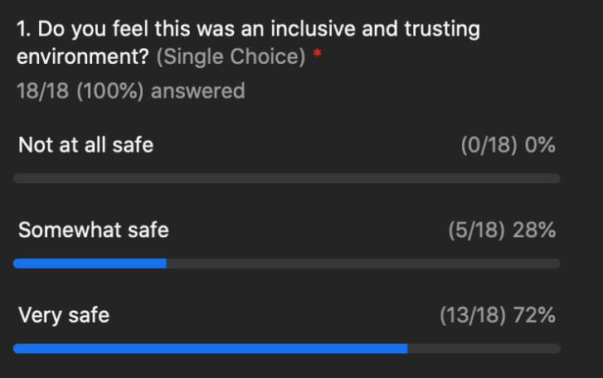

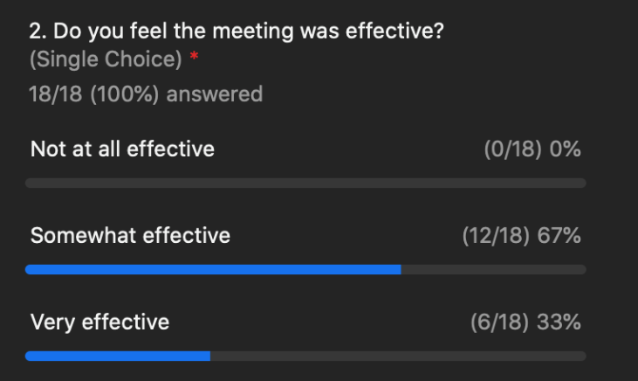

**Appendix A: Attendance**

|  |  |  |
| --- | --- | --- |
| **Attendance for Feb 3, 2022 CDEI Working Group Meeting #2** | | |
| **Working Group Member Representatives & Alternates** | | |
| **Organization** | **First** | **Last** |
| 3C-REN | Alejandra | Tellez |
| CEE | Bernie | Kotlier |
| CEE (alternate) | Alex | Lantsberg |
| CSE | Fabi | Lao |
| Don Arambula Consulting | Don | Arambula |
| Don Arambula Consulting (alternate) | Elizabeth | Lowe |
| Energy Efficiency Council | Allan | Rago |
| Energy Efficiency Council (alternate) | Ron | Garcia |
| Future Energy Enterprises (alternate) | Scott | Shvartsman |
| Greenbank Associates | Alice | Sung |
| ICF | Dany | Kahumoku |
| La Cooperativa Campesina de California | Robert | Castaneda |
| NRDC | Lara | Ettenson |
| SCE | Patty | Neri |
| SEI (Strategic Energy Innovations) | Jake | Pollack |
| Silent Running LLC | James | Dodenhoff |
| SJVCEO | Kelsey | Jones |
| SoCalREN | Fernanda | Craig |
| The Energy Coalition | Melanie | Peck |
| Viridis Consulting, LLC | Mabell | Garcia Paine |
| **Ex-Officio** | | |
| CPUC | Nicole | Cropper |
| CPUC | Peter | Franzese |
| CPUC | Alison | LaBonte |
| CPUC | Yeshi | Lemma |
| CPUC | Nils | Strindberg |

**Appendix B: Breakout Ideation Summaries**

The screenshots below are from the jamboards used during the meeting. Jamboard is a technology used to capture ideas, essentially virtual sticky notes.

