Proposal from the California Energy Efficiency Coordinating Council (CAEECC) for Improvements to the EE Portfolio Approval and Budget Authorization Process

1.0 Background
In May 2019, the Public Advocate’s Office (CalPA) distributed a Straw Proposal on energy efficiency (EE) Approval Process Improvements to the California Energy Efficiency Coordinating Committee (CAEECC) (see Appendix A). The CalPA’s Problem Statement identified a number of areas in which the current process of a 10-year Business Plan with Annual Budget Advice Letters (ABALs) was failing to deliver on the benefits that had been envisioned when the process was designed.
Following discussion at several CAEECC meetings, the CAEECC initiated a CAEECC-Hosted Working Group on Energy Efficiency Portfolio Filing Processes. The Working Group met three times in October, November and February—with several sub-Working Groups meeting on specific topics in between. See full Working Group Members that included PAs, CalPA, and various CAEECC Members in Appendix B.
There was general agreement among Working Group members that the current process needs improvement to deliver on the goals of:
- CPUC commitment to long-term funding availability for all cost-effective EE
- reasonableness of savings and budget forecasts
- meaningful oversight of PA budgets and activities
- reduced administrative burden, and
- flexibility for PA and program implementers to respond to market and policy fluctuations

While strong in concept, in practice the “rolling portfolio” business plan application process covering 10-years of authorized funding contained limited information on and review of forecasted budgets, savings, and cost-effectiveness. This lack of detail in the approved business plans required that the scope of Annual Budget Advice Letter (ABAL) review, designed to be ministerial in nature, include non-ministerial factual and policy questions that proved difficult for Commission staff to resolve in a timely manner that is consistent with Commission decisions.
As such, to improve upon the “rolling portfolio” and business plan construct, the scope and level of detail in future EE application proceedings must increase substantially so that the Commission, and stakeholders, can resolve factual and policy disputes in these formal proceedings.
The Working Group formed two sub-Working Groups to flesh out four-year and six-year filing alternatives. Below represents the proposal of the four-year sub-Working Group.

2.0 4-Year Proposal Overview
The 4-year sub-Working Group (4-year sub-WG) proposes modifications to the existing EE “rolling portfolio” and business plan construct. Namely, the 4-year sub-WG recommends:
- A four-year portfolio cycle with four-year cumulative total of first year net portfolio energy savings goals and a 4-year cost-effectiveness threshold requirement
- An EE application process that includes a robust budget and cost-effectiveness showing with supporting testimony
- Full-cycle budget showing for program implementation costs and a “test year + attrition years” showing for portfolio administration costs
- An updated EE reporting structure that uses program administrators’ (PAs’) EE Annual Reports as the main vehicle by which to assess on-going portfolio and program performance against Commission-approved metrics and indicators
- Other interim filings only on a limited basis if certain pre-specified triggers occur

3.0 Objectives and Benefits
With a four-year EE portfolio cycle and modified EE application process, the WG intends to:
- Provide confidence to the Commission, stakeholders, and customers (ratepayers) that program administrators’ EE portfolio proposals, and budget and cost-effectiveness forecasts, are reasonable and just, and that any factual and/or policy disputes were appropriately and formally addressed
- Provide confidence to program administrators, market actors, customers, other state agencies (i.e., CAISO) and stakeholders that the CPUC commits to long-term and ongoing funding for all cost-effective energy efficiency as determined by the CPUC’s (biennial, triennial etc.) potential and goals decision, and required by PUC 454.55
- Allow program administrators and program implementers a sufficient time horizon to plan and implement portfolios and programs that meet the state’s long-term EE, equity, and GHG reduction goals
- Afford program administrators, program implementers and relevant stakeholders the flexibility required to adapt to any market fluctuations, incorporate new policy considerations, and allow programs to naturally evolve through their anticipated lifecycles
- Reduce administrative burden and associated costs that come with extraneous regulatory touchpoints
- Align portfolio cycle and funding timing with other distributed energy resources (DER) proceedings to support integration
- Align portfolio goal inputs and portfolio implementation and assessment to provide market stability for Third- Parties, IOUs and regulators.

4.0 Portfolio Review and Oversight

4.1 EE Application
The PAs will follow a four-year portfolio cycle, reviewed and approved by the Commission via an EE application filed by the end of the third year of each four-year portfolio cycle. The cycle that the 4-year sub-WG proposes would begin as soon as possible (e.g., with the first four-year portfolio cycle covering years 2023-2026, with PAs’ applications filed in late 2021).
The four-year portfolio cycle supports dynamic portfolio management and affords PAs the flexibility to meet goals and spend authorized budgets over multiple years, recognizing natural market fluctuations and program on/off ramps. The purpose of the PA’s EE applications is to articulate its overarching strategy to support the state’s EE goals and objectives, describe programmatic plans for each sector, and seek formal EE funding approval.
The EE application will include budget, savings, and cost-effectiveness forecasts, through detailed testimony, to ensure a robust and sufficient record to inform Commission decisions. The Commission will determine the need for hearings based on the contents of application and testimony.
To provide PAs a stable policy framework on which to develop EE portfolios, we recommend that the Commission issue a Guidance decision at least 9 months before the EE application filing date. As it has been used in EE rulemaking proceedings in the past, the Guidance decision acts as the governing document for the inputs that the PAs would utilize for forecasting the upcoming four-year program cycle and application. The Guidance decision would set technical input values for the submission of an Application. The Commission should initiate development of an appropriate evidentiary record, likely via ruling(s) and comments in an open rulemaking proceeding, and issue a Guidance decision based on that record on a timeline that permits PAs to thoughtfully and fully incorporate the Commission’s guidance in their applications. For example, the Guidance decision could articulate relevant policies and technical inputs to be used for the application, including: avoided costs, potential and goals, and other ex-ante technical parameters such as DEER, eTRM, versions and industry standard practice (ISP) baselines.
PAs’ EE Annual Reports, submitted every May, will include sufficient detail on portfolio, sector and program-level annual and cumulative accomplishments, including data on savings, budget, cost-effectiveness, and other approved metrics to ensure accountability and public input on the progress of portfolio performance. The Annual Report will also present a prospective overview in narrative format that will include future plans to meet and/or exceed the cumulative 4-year energy savings goals and the 4-year cost-effectiveness requirement. The prospective overview will include any program adaptations, additional solicitations, or other strategies that may be necessary to help ensure attainment of the 4-year energy savings goals and the portfolio cost-effectiveness requirement. Each PA will post its Annual Report on the CAEECC website and provide a high-level overview of its Annual Report at CAEECC (see Stakeholder process below). [Facilitator note: This sentence to be updated when the 4-Yr Sub WG discusses Section 8.0 on Stakeholder Process on next call]

4.2 Interim Filings
It is important to clarify the distinction between trigger-based Interim Filings and any specific and required Mid-Cycle Filing. Interim filings may be needed between Applications in order to document or gain CPUC approval for a PA’s portfolio change. For example, the current filing requirement should remain in place for a PA to file a Tier 2 Advice Letter when closing a program. As such, Interim Filings are considered “trigger-based” and can happen at any point in the cycle.
A Mid-Cycle Filing, for purposes of this proposal, would be a specific filing around the middle of the 4-year cycle to report on portfolio performance to that point. The WG has debated the value of a mid-cycle filing given the existing reporting mechanisms and the timing of a 4-year cycle which requires a PA to prepare their next Application shortly after the mid-point of the previous cycle. This timing raises questions about the impact of an ED disposition on a mid-cycle filing if that filing overlaps with and/or is superseded by an Application.

4.3 Trigger Based Filings
In the event that a PA requires any of the following changes to its portfolio, the PA would submit the filings as shown below:
Portfolio Change/Trigger | Filing
•Program closure | Tier 2 Advice Letter
•Additional budget (beyond authorized 4-yr portfolio budget)  •Portfolio not on target to meet 4-yr cumulative savings goals or cost-effectivenessthreshold | New Application
Other? | XX
As described in Reporting Requirements (below), the existing CEDARS and Annual Report submissions would be the primary tools with which the PAs would report their progress and accomplishments to the CPUC and stakeholders. In addition to its retrospective content, we propose that the Annual Report template be amended to include a prospective narrative describing future portfolio and program initiatives a PA intends to implement to meet metrics and goals for the cycle.

4.4 Mid-Cycle Filing Options
Option 1: The 4-year sub-WG recommends that no Mid-Cycle filing be required. Instead, the PA’s Year 2 Annual Report will be the vehicle for reporting on progress made in the first 2 years. Given the timing of a 4-year cycle, PAs will be planning their next Application as their Year 2 Annual Report is being finalized – thus a PA will be responsible for clearly demonstrating in their Application how they are learning from their performance and experience in years 1 and 2 and are setting themselves up for success and improvement in the next cycle.
Option 2: If a Mid-Cycle filing is required, then the 4-year-sub-WG recommends a Tier 1 advice letter be filed with the Year 2 Annual Report (in May of Year 3). The advice letter would reference the Annual Report and would allow for stakeholders to provide comments, if necessary.

5.0 Application Structure and Contents
The EE Application will include the PAs’ portfolio plan, and budget and cost-effectiveness showing. Each section of the EE application will be supported by witness testimony providing justification as to its reasonableness.

5.1 Portfolio Plan
The portfolio plan section of the EE Application is designed to describe each PA’s vision, strategy and approach to meet the state’s EE, equity and GHG goals. The portfolio plan focuses on long-term and short-term strategic objectives by sector (e.g., Residential, Commercial, Public, Industrial, Agricultural, Cross-cutting), with associated tactics (i.e., programs or intervention strategies) designed to achieve the strategic objectives. This section describes the metrics and indicators, including energy savings goals and GHG targets, and milestones for each strategic objective and programmatic activity. Implementation Plans (IPs) will not be included as part of the formal application process. Rather, PAs will continue the IP process described in D.15-10-028.

5.2 Budget and Cost-effectiveness Showing
PAs will justify the reasonableness of budgets and savings and cost-effectiveness forecasts through detailed showings of current and proposed expenditures and zero-based budgeting exercises as well as detailed testimony on forecasting inputs, methods, and results. Generally, there are two types of costs, with potentially different regulatory treatment for each—program implementation costs and portfolio administration costs.
Program Implementation Costs: All costs associated with delivering a program. With the use of 3rd party implementers, this is very straightforward; all costs associated with contracts for efficiency programs is program implementation. Should the program administrator be in the role of implementation, the PA should clearly identify all costs associated with that program. This should NOT be some level of “rule of thumb” allocations. PA employee time (including account reps) should be booked directly to a specific program being implemented in a manner that can be audited for accuracy. The PA could propose methods for tracking things like traditional “overhead” (such as rent, or IT services) in a manner that appropriately links to employee charged time.

Portfolio Administration (ie: Overhead): Everything else not in Program Implementation. Cost for things like managing a solicitation, negotiating a contract, and reviewing/paying invoices all are part of Administration (this should not be put into the “implementation” bucket).

For all program implementation costs, PAs will provide detailed showing and justification for the entire four-year portfolio cycle.
For all portfolio administration costs, PAs will provide a detailed showing and justification either:
- The first year (or “test year”) of the portfolio cycle with related budgets for subsequent years (also known as “attrition years”) based on the approved budget for the first year, adjusted by a limited range of factors. These include significant known and planned adjustments (e.g., a measure or group of measures accounting for significant savings going into code) and an escalation factor as appropriate, or
- A detailed showing each year if a PA anticipates large variances year-over-year.
The choice between A or B above would be at each PAs discretion.
Regardless of type of cost (i.e., program implementation vs. portfolio administration) zero-based budgeting is a cornerstone of the required showing for all costs, wherein PAs justify in detailed testimony the reasonableness and prudence of forecasted expenditures. The showing includes a detailed presentation of forecast costs in all significant cost categories (e.g. labor/non-labor/capital/contract costs; admin/implementation/marketing costs; sector by sector costs, etc.). Additionally, the budget showing includes comparisons to recent expenditures in the relevant budget categories to assess trends and adjust for changing circumstances. Further, testimony and exhibits demonstrate the reasonableness of the forecasts in light of historical performance, including realization rates, impact evaluation adjustments, and other relevant information. As in all application proceedings, the burden rests with the PA to demonstrate the reasonableness of the application.
The Commission would approve funding for program implementation-related costs based on the detailed budget testimony and supporting workpapers and exhibits covering all years in the full application cycle. For portfolio administration-related costs, the Commission would approve funding for either A) the test year, requested adjustments for subsequent years, and the associated revenue requirements for each year; or B) the detailed costs for each year over the four year cycle.
In this application process, PAs continue to maintain their fund shifting flexibility consistent with dynamic portfolio management and as authorized in D.15-10-028.
Significant changes in the EE ecosystem affecting budgets, savings, and cost-effectiveness may result in the PAs needing to file new EE applications (see Section 4.3).

6.0 Potential and Goals, Avoided Costs, and Technical Inputs Framework
To ensure the success of a four-year portfolio cycle, we recommend that the Commission adopt cumulative energy savings goals for a four-year period (with a 2-year refresh). EE applications would be designed to meet and/or exceed four-year cumulative portfolio energy savings goals and portfolio cost-effectiveness thresholds.
The Potential and Goals study would continue to cover a ten-year planning horizon to appropriately align with CEC’s Integrated Energy Policy Report (IEPR), and CPUC’s Long-term Procurement Planning Proceeding (LTPP) and Integrated Resource Planning (IRP) processes.
EE is dynamic and its policies and technical values are almost constantly being updated. We recognize that these ongoing changes, and the annual “bus stops” in which new values are adopted, can result in misalignment with the EE Goals which are only updated every other year. Additionally, after the current two year update, inputs and assumptions continue to change. The misalignment can also lead to challenges for the PAs when they are preparing budget filings and applications while critical input values are actively changing.
A process update is needed to address the issue of misalignment between EE Goals and the changes in EE potential that result from annual updates of values such as avoided costs and DEER parameters, and ad-hoc changes to ISP baselines and EE policies. We recommend that the CPUC align portfolio implementation and assessment with the Potential and Goals Study using the following graphic.
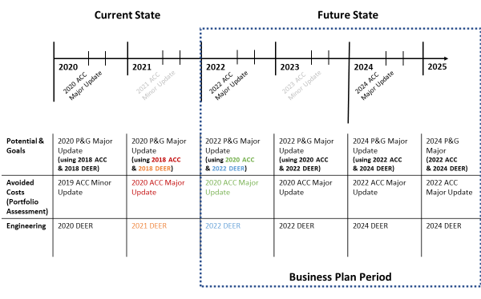
Figure 1: Preferred Option - Biennial P&G Updates
Preferred (Biennial) Option: Biennially update the savings Goals to adjust for updated technical inputs, DEER values and major updates to avoided costs, then maintain these inputs for the 2 year P&G period.
  - Avoided Cost: Incorporate the most recent IDER Major Avoided Cost updates into the P&G Study similar to the 2016/2017 Avoided Cost update being aligned with the 2018 P&G Study. Maintain the avoided costs for portfolio implementation and assessment for the 2 years aligned with the P&G study.
  - Technical Inputs: Incorporate latest engineering values into the P&G study. Previously the study used engineering values that were three years older than the values used in portfolio assessment. Now DEER updates are n+2 allowing for P&G inputs to align with the Start year of the study. Maintain the technical inputs for portfolio implementation and assessment for the 2 years aligned with the P&G Study.
  - Calibration: Utilize the most current program data from CEDARS. Current P&G Study calibration stops at 2016 data due to the switch from EE Stats to CEDARS and model limitations.
  - Changes: Incorporate erroneous values as required, maintain inputs until the next P&G update.
  - Administration: Adjusts current P&G study process to align with input availability, maintains stakeholder input opportunities, provides market stability for Third-Parties and PAs, and does not increase CPUC staff burden. Aligns with the 2nd year annual report process described in Section 4.1.
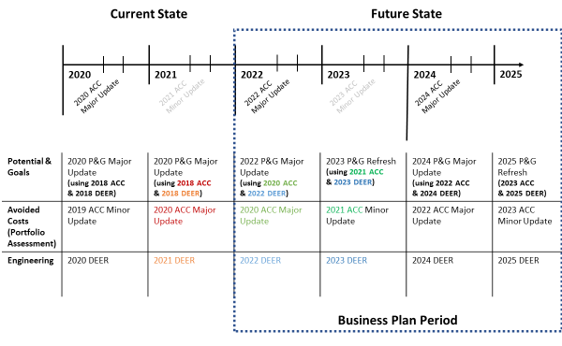
Figure 2: Alternate Option - Annual P&G Refresh
Alternate (Annual) Option: Update the Potential and Goals Study annually with the latest technical inputs , DEER values and major updates to avoided costs. In years when a full P&G Study is not being conducted, the P&G team would conduct only a smaller “off-year update”.
  - Avoided Cost: Incorporate most recent IDER Avoided Cost updates into the P&G Study and off-year updates. This approach would incorporate both major and minor updates. Update the avoided costs for portfolio implementation and assessment to align with the P&G Study off-year update.
  - Technical Inputs: Incorporate latest engineering values into the P&G study and off-year updates. Update the technical inputs for portfolio implementation and assessment to align with the P&G Study off-year update.
  - Calibration: Utilize most current program data from CEDARS. Current calibration stops at 2016 data due to the switch from EE Stats to CEDARS and model limitations.
  - Changes: Incorporate erroneous values as required, maintain inputs until the annual P&G update.
  - Administration: Increase frequency of current P&G Study process to an annual basis and/or truncated stakeholder feedback periods, utilizes best available data for Third-Parties, IOUs and stakeholders.

7.0 Reporting Requirements
To provide the Commission and its staff, as well as stakeholders and market actors visibility into PAs’ portfolio and program initiatives, PA’s will continue to submit quarterly data reports via the CEDARs platform. Quarterly reports consist of a data submission on a PA’s progress on savings, expenditures and other targets.
PA’s EE Annual Reports serve as the main vehicle to assess on-going portfolio and program performance against Commission-approved goals, targets, metrics, and indicators. The Annual Report provides a retrospective cost-effective showing, along with annual and cumulative progress on savings, expenditures, and other approved metrics. The Annual Report will include a prospective narrative that describes upcoming portfolio, program, and solicitation initiatives PAs intend to implement to meet and/or exceed goals. Over the course of the portfolio cycle, the Annual Report data allows PAs, the Commission and its staff and other relevant stakeholders to assess trends and adjust as necessary. The final Annual Report, submitted Year 5, will include a comprehensive dataset reflective of the four-year portfolio cycle. Annually, PAs will present Annual Report data to CAEECC for discussion and input on any necessary directional changes, as described in more detail below.

8.0 Stakeholder Process
[TBD; being developed by other CAEECC WG members]

9.0 Application Filing Timeline
The following timeline illustrates the various Commission and staff, PA, and stakeholder activities and timeframes to implement the proposed four-year portfolio cycle.
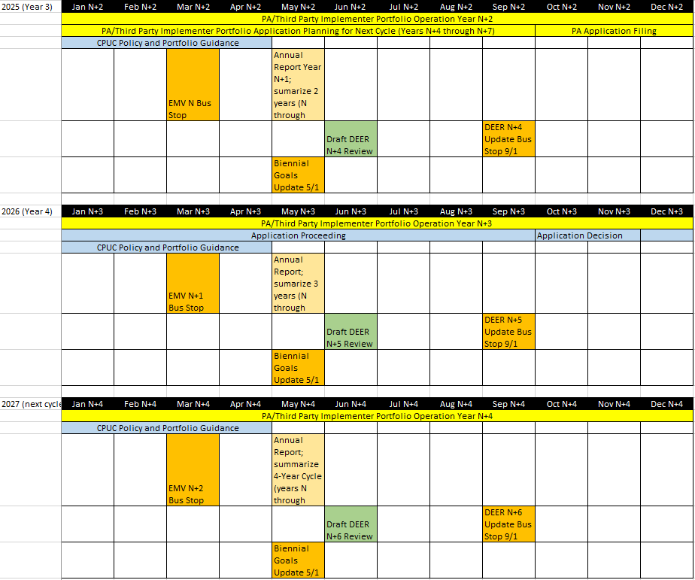

Appendix A: “4-Year Working Group Members”
The following Working Group Members (and their organizations) support a 4-year budget application cycle:
- Athena Besa, SDG&E
- Ryan Chan, PG&E
- Erin Brooks, SoCal Gas
- Cody Taylor, SCE
- Mike Campbell, Public Advocates Office
- Lara Ettenson, NRDC
- Dave Dias, SMW Local 104
- Raghav Murali, Center for Sustainable Energy
- Dan Suyeyasu, CodeCycle

“On-target” is defined as PA reasonably able to demonstrate its ability to meet savings and cost-effectivness targets by the end of the four-year cycle. In other words, if the PA is short in a given year, they can reasonably "make it up" in the following year(s).
Four-year cumulative total of first year net portfolio energy savings goals
Zero-based budgeting is a method of budgeting in which all expenses must be justified for each new period. The process of zero-based budgeting starts from a "zero base," and every function within an organization is analyzed for its needs and costs.
Four-year cumulative total of “first-year net” portfolio energy savings goals

