[PG&E Logo to be added 12/1]

Business Energy Performance Program

Implementation Plan

December 7, 2020
Version 1.0

Table of Contents
Program Overview 3
Program Budget and Savings 3
1. Program and/or Sub-Program Name 3
2. Program / Sub-Program ID number 3
3. Program / Sub-program Budget Table 3
4. Program / Sub-Program Gross impacts table 3
5. program / Sub-Program Cost Effectiveness (TRC) 3
6. program / Sub-Program Cost Effectiveness (PAC) 4
7. Type of Program / sub-program implementer 4
8. Market Sector(S) 4
9. program / Sub-program Type 4
10. Market channel(S) and intervention strategies, Campaign Goals, and Timeline 4
Implementation Plan Narrative 4
1. Program Description 4
2. Program Delivery and Customer Services 4
3. Program Design and Best Practices 6
4. Innovation 8
5. Metrics 9
6. For programs claiming to-code savings 10
7. Pilots 10
8. Workforce education and training 10
9. Workforce standards 10
10. Disadvantaged worker plan 11
11. Additional information 11
Supporting Documents 11
1. Program Manuals and Program Rules 11
2. Program theory and program Logic Model 11
3. Process Flow chart 13
4. Incentive Tables, Workpapers, Software Tools 14
5. Quantitative Program Targets 14
6. Diagram of Program 15
7. Evaluation, Measurement & Verification (EM&V) 15
8. Normalized metered energy consumption (NMEC) 16

Program Overview
The Business Energy Performance (“BEP”) Program (“Program”) is a downstream program that will provide energy efficiency services, technical assistance and incentives to the Petroleum, Chemical, and Minerals sub segments within the Pacific Gas and Electric (“PG&E”) service territory.
The program will provide the following services:
- Marketing and outreach
- Customer education and facility benchmarking
- Technical assistance and long-term energy efficiency planning
- Project scoping and development
- Financial incentives/rebates
- Inspection and verification of project results
- Promotion of financing options, such as On-Bill Financing (“OBF”)

Program Budget and Savings

1. Program and/or Sub-Program Name
PG&E Business Energy Performance (BEP) Program

2. Program / Sub-Program ID number
PGE_Ind_002

3. Program / Sub-program Budget Table
 | 2020 | 2021 | 2022 | 2023 | Total
Admin | $83,588 | $425,061 | $722,332 | $908,103 | $2,139,084
Marketing and Outreach | $41,794 | $212,531 | $361,166 | $454,052 | $1,069,543
Direct Implementation - Non-Incentive (DINI) | $292,557 | $1,780,400 | $2,988,723 | $3,736,853 | $8,798,533
Incentives | $0 | $2,228,357 | $3,568,870 | $4,495,133 | $10,292,359
Total | $417,939 | $4,646,349 | $7,641,091 | $9,594,141 | $22,299,520

4. Program / Sub-Program Gross impacts table
Program Goals
2021 Program Year |  |  | 2022 Program Year |  |  | 2023 Program Year
Gross kWh | Gross kW | Gross therms | Gross kWh | Gross kW | Gross therms | Gross kWh | Gross kW | Gross therms
14,202,110 | 1,584 | 1,491,574 | 22,380,592 | 2,698 | 2,368,510 | 27,057,477 | 3,586 | 2,891,552

5. program / Sub-Program Cost Effectiveness (TRC)
Program ID Number | TRC (no admin)
PGE_Ind_002 | 2.02

6. program / Sub-Program Cost Effectiveness (PAC)
Program ID Number | PAC (no admin)
PGE_Ind_002 | 4.63

7. Type of Program / sub-program implementer
Local - Third party delivered

8. Market Sector(S)
Industrial

9. program / Sub-program Type
Resource

10. Market channel(S) and intervention strategies, Campaign Goals, and Timeline
Downstream; Incentive, Finance, and Technical Assistance. Campaign goals: 63,640,179 Gross kWh, 6,751,636 Gross therms over 3-year program.

Implementation Plan Narrative
1. Program Description:
The Program will provide energy efficiency services, technical assistance and incentives to the industrial sector within the PG&E service territory. The Program will target the Petroleum, Chemical, and Minerals sub segments using a downstream market approach and predominantly leveraging the Deemed and Custom savings platforms to deliver cost-effective energy savings. The Program will also promote and leverage on-bill financing (“OBF”) and the California Hub for Energy Efficiency Financing (CHEEF) as a tool to off-set the barrier of capital to fund projects.
The primary objectives informing the program design are:
- Increase the cost-effective savings achieved in the industrial sector
- Support long-term energy efficiency planning and continued customer engagement to maximize savings delivery
- Clearly establish and document influence and standard practice to provide eligibility and planning clarity to customers

2. Program Delivery and Customer Services:
The Program will deliver downstream energy savings through the following energy efficiency calculation platforms:
- Prescriptive
- Custom calculated
Customers will be identified and funneled into the appropriate platform based on their individual needs, savings opportunity, and efficiency goals.

Customer Outreach:
The Program will leverage multiple customer outreach strategies to drive awareness of energy efficiency offerings and engagement. This includes a data-driven analysis of savings potential and past participation paired with qualitative information on the customer decision making processes and market pressures to determine the best candidates for outreach. Based on this analysis the Program will reach out to customers directly with marketing messages and direct account management. The Program also will work with industry organizations and vendors to drive awareness of the offering.
Direct customer outreach will be the key tactic to drive customer participation. The Programs’ outreach and account management team will focus on face-to-face meetings, email and phone calls to create and sustain relationships and drive Program adoption. The strategies outlined below will be continuously built upon by the outreach team as the account managers continue to engage deeper in the market. Regular reviews will be conducted of these resources to assess relevance, and to make sure there are adequate resources to drive the desired results.
Lead generation will come from a variety of sources including:
- Direct to customer marketing
- Program and PG&E account managers
- Manufacturers, distributors and vendors serving these segment
- Industry and trade organizations
Prospective customers will be contacted and introduced to the program at a high level to gauge their interest and business needs. Collateral, which is specific to the customer need, will be used to educate the customer about the benefits of participation and help them identify best-fit solutions for their business. The account managers will ensure that customers are supported as they move through the program. The Program will focus on customer satisfaction as repeat participation and word-of-mouth are key program savings strategies.
The Program team will be able to speak to other programs and opportunities that support the sustainability goals of customers in these sectors. This will help eliminate customer confusion about multiple program offerings and will coordinate with existing statewide and local government programs to avoid overlapping customer outreach activities.

Support Tactics:
Other marketing tactics that will support customer lead generation and account management include:
- Collateral: Sector specific educational materials that convey the energy and non-energy benefits associated with custom projects and other offerings. These materials will educate customers about the long-term benefits of energy efficiency, available incentives, and other programs that may help. Program collateral will include:
  - Program overview
  - Industry specific info sheets
  - Measure specific info sheets
- Case Studies: Descriptions of specific projects that have been implemented by customers in California will be a key tool for account managers to use in encouraging customers to participate. Case studies will be developed on a wide variety of measures and industry type to equip the outreach team with specific examples of completed projects to show customers.
- Web Content: There will be a dedicated website to promote the Program and provide valuable information to potential customers and other stakeholders. Initial content includes incentive details, FAQs, and high-level program information and will be supplemented by case studies and other collateral as developed. Customers visiting the website will be able to access the customer portal as well as contact information to reach Account Managers.
- Trade Associations: Trade associations are trusted partners in the business community and provide another avenue for reaching target sectors. CLEAResult will reach out to local trade associations and business leader groups to raise program awareness.

Services Provided:
- Dedicated Energy Advisors provide personalized attention, follow–through, and assistance in identifying solutions that meet customers’ needs, budget, and levels of readiness for change.
- Facility Audits: Targeted facility audit to provide a peripheral view of the facility and operating systems to assist in development of a list of potential measures and opportunities.
- Technical Assistance: The Program will offer technical assistance to customers to help them understand the full scope of available resource conservation options and guide customers through the process from project identification to completion.
- Financing: Integrated financing options provided to reduce the need for capital investment in energy efficiency measures.
- Incentives: Financial incentives provided to off-set costs of energy efficiency measures.

3. Program Design and Best Practices:

Program Design:
The program is designed to meet the needs of a diverse range of industrial customers, with a flexible incentive structure and multi-track engagement approach that guides each participant to the path that is right for them. The Program will also use this process to identify which program pathway might be the best fit for each customer. The Program will:
- Combine incentive and financing resources to reduce costs, align with benefits, and reward savings.
- Carefully consider customer journeys and value propositions, tailored to support varied customer decision networks, make participating simple and attractive.
- Form meaningful links between energy savings and internal priorities, such as increased production or employee retention.
- Reduce complications associated with vetting and approving new products for incentives through our expert engineering analysis of market opportunity and strong regulatory presence and relationships.
The Program will tailor the customer experience based on the individual needs and goals of each customer: technical support through industry specific engineers, customizable tools, partner services, and best practices informed by insights from other programs targeting similar customer segments. The close engagement with each customer will foster the ability to guide them towards the participation track best suited to their organizational structure and goals – from more straightforward deemed measures to highly technical custom measures.
Following the initial customer engagement, The Program will match them with a dedicated energy advisor who will provide ongoing support, guidance, and follow-up communication throughout their participation experience. Additionally, this initial engagement will be used to schedule and perform a Facility Assessment tailored to the customer’s size and potential, and determine the track (custom or deemed incentives) best suited to identified project opportunities.
Understanding that the local workforce represents a key customer touchpoint, The Program will provide trade allies with the strong, comprehensive tools and training they need to help customers navigate the decision-making process and drive project adoption. The Program will leverage this network to utilize our established best practices in program ally outreach and engagement to convey the benefits of relevant energy-efficient measures, best practice installation guidelines, and PG&E-specific requirements.

Market Barriers:
While these markets, and their sub-markets, are different in many ways, industrial customers face many challenges in participating in energy efficiency programs. Many have challenges understanding how best to evaluate and implement cost-effective energy efficiency improvements due to limited bandwidth and/or hesitation to adopt new technologies. In addition, customers in these segments have unique operations and variable conditions driving complexities in program ease of use, business priorities, opportunity identification, and value quantification. Due to competing priorities for resources within a customer’s business, it is a challenge to gain the attention of key decision-makers without having a succinct and proactive energy efficiency strategy that will bring financial and operational benefits to a customer immediately and in the years to come. Improving the efficiency of the equipment and processes driving their business is often not the priority of the facility staff. The unique needs of some customers will necessitate a deeper level of support and engagement to ensure successful project completion.
For example, responsible for about one-quarter of the industrial sector’s electric and gas usage, PG&E petroleum customers can contribute significant savings through completion of large, cost-effective projects. Yet energy efficiency program participation has been historically low and is currently trending downward, largely due to uncertainty around access to energy efficiency funds, ambiguous or inconsistent policy applications, and long project approval timelines.
Unlike other segments where savings opportunities exist across widely varied organizations, this sub-segment is dominated by a relatively small number of large consumption facilities. Recently, the oil and gas market has seen a significant amount of disruption due to drops in the price of oil, new state regulatory requirements, and a significant number of merger and acquisition activities. Due to this increased volatility, producers are more critical in their project evaluations, and can struggle to justify capital investments beyond what is required to ensure safe and continued operation. Similarly, the chemical and mineral subsegments have their own unique challenges that impact their operations and decision making. Our target customers therefore require high-touch engagement to keep EE opportunities relevant and top of mind.
To overcome these barriers, industrial customers need a multifaceted approach – not solely an incentive or rebate offer – tailored to meet their specific business requirements. This program design will introduce a tiered approach to program participation so the relationship can begin at the level most appropriate for the individual customer given their priorities, energy savings opportunities, and internal decision-making process and timing. Table 1 below details how The Program will minimize the barriers of participation.
The Program includes strategic interventions to solve persistent barriers to industrial customer participation, including:
- Financial constraints inhibiting pursuit of large equipment or system upgrades – including complex internal capital expenditure authorization requirements, limited budget for energy efficiency work, and a fixed budget cycle that requires project planning years in advance – can be addressed through right-sized and transparent incentive structures and integrated financing.
- The complex decision-making matrix and internal processes, unique to this segment, can be more effectively navigated using BEP’s holistic participant engagement approach.
- Participants may be aware of operational inefficiencies but not understand the link between diverted energy waste and available incentives, which the program will establish through upfront technical analysis, initial quick-win incentives, and frequent communication regarding incentive status.
- Lack of confidence in incentive availability or understanding of requirements to obtain funding leading to low participation and skepticism of the process. This is addressed through early establishment of program influence, proven project development protocols and clear and transparent communication.

Table 1 below details how The Program will minimize the barriers of participation.
Table 1. Market Barrier, Risks, and Risk Management Strategies
Market Barrier | Risk | Risk Management Strategies
Financial risks around measure performance and equipment downtime | - Decision-makers choose to install cheaper, less efficient equipment with shorter payback/IRR, resulting in lower savings  - Customers place priority on fluctuating commodity prices | Flexible incentive process and performance-based incentives provide incentives to reduce the initial cost of retrofit or system upgrades
Complex decision-making process and long-term planning | - The planning cycle may miss the opportunity to adopt energy efficiency | Energy Advisors help to inject energy management into long-term planning process
Siloed opportunities for energy improvements by product type | - Program misses out on significant energy savings toward meeting goals | Conduct innovative technical analysis both in field and remotely to identify participants and opportunities
Lack of awareness of energy efficiency opportunities and value to business | - Customers see no need to replace functioning equipment  - Customers are not informed about the most efficient equipment available when the need to replace it is immediate. Some efficient equipment may have a longer delivery time that would affect customer operations | Energy Advisors build awareness, trust, and engagement

Best Practices:
The Program will promote a comprehensive approach to energy efficiency projects, available to qualifying customers through a range of outreach and marketing tactics. The program will work directly with customers to help identify, develop, and implement qualifying projects.
Components of implementation, include:
- Engaging industry partners across PG&E’s service area to provide maximum customer value and increase the rate of customer participation
- Educating customers on energy efficiency opportunities and directing them to the program through direct interaction, and marketing activities and materials
- Utilizing technical support to complete targeted facility assessments to aid in identification of potential opportunities
- Educating and developing an effective network of contractors, trade allies, and distributors to encourage energy efficient installation decisions among their customers
- Providing an option for customers to complete on-line portal, program applications, or work with trade allies to complete on-line portal applications
- Reviewing pending and completed project documentation to verify the applicant is an eligible customer operating within the PG&E service territory, and the completed project and installed equipment meets program eligibility requirements
- For applicable project types, working with customers to confirm project pre-approval via email, before contracting for, ordering or installing energy efficiency equipment and/or services
- Processing completed applications and issuing rebates for qualified projects/equipment
- Verifying completed equipment installation for a sample of participants to confirm program integrity as a part of M&V efforts.

4. Innovation
The Program’s design represents an industrial delivery evolution that leverages the most innovative features proven to effectively serve this market while introducing new strategies supported by rigorous analysis. Our innovations will result in a more cost-effective program that accelerates advancement towards the PG&E and statewide goals of doubling EE savings in the industrial segment. This design will directly benefit PG&E customers – driving higher participation rates, increased satisfaction, and deeper engagement to ensure continuous improvement and savings persistence.
Increased Participation
Statewide savings goals cannot be achieved simply by continuing to serve industrial customers who have been energy leaders over the past decade. Reaching currently untapped customers and savings opportunities cost-effectively requires targeted engagement supported by clear, customized value propositions for each facility’s decision-makers. The Program will thoughtfully align customer outreach with recommendations for best-fit energy efficiency options, personalizing communication with energy insights that include, but are not limited to:
- Business type
- Peak demand and load factor
- Propensity to act or participate in programs
We can then match each customer with the right solutions for their business, maximizing participation and project completion.
Deep, Persistent Savings
Our targeting approach and use of monitoring and feedback on project results will drive deeper, persistent savings from the industrial sector. Research on program effectiveness consistently demonstrates how analytical targeting can significantly improve program performance.
Analytical Targeting
CLEAResult was one of the first firms to pilot analytical targeting with PG&E during the analytics enabled RCx program pilots of 2013-15. While changing rules related to RCx prevented the continuation and scale-up of those programs, our experience and evidence for the potential impact of targeted approaches has directly informed the Program design. Key learnings we have drawn on include:
- Remote analytics provide a good indication of the site savings potential,
- Specific solutions for delivering on that potential must be determined with additional information collected on-site
- Relative comparisons of site savings potential are valuable in reducing effort that would otherwise be spent screening sites with limited savings potential
- Site decision-makers’ commitment to a project is a key indicator of success, and that commitment can be bolstered by early, analytics-driven assessment of potential
Based on research conducted, analytical targeting, and our own experience piloting this approach, CLEAResult has a deep understanding of what use analytics can realistically deliver in this market. Our central approach relies on precision-based targeting and outreach, leveraging existing data sources and our innovative benchmarking approach to identify the highest-value targets across a broad range of energy management opportunities, with facility-specific analytics used to transform customer interactions into personalized engagements. While it can deliver increased savings per project and help secure upfront commitment, it cannot replace on-site audits or the strong customer support needed to move a project from concept to reality.
Financing
Integrated financing will further drive program success. OBF will remain the most attractive finance offering for many customers and will be promoted heavily through the Program. However, we know that for other customers and for program allies, the true upfront capital offered through our relationships with energy efficiency lenders will enable larger projects with deeper savings. OBF loan funds are not available until after project installation, verification and approvals. In some cases, this occurs up to a year after the customer requires initial project funding. Private access to capital can fill that gap to provide a cash flow neutral or positive position for the customer throughout the project lifecycle, unlocking currently untapped savings from the industrial segment.
Monitoring and Feedback
The Program will ensure projects perform according to initial estimates and deliver deep savings through monitoring and feedback mechanisms. The ability to measure and share results is frequently cited as a factor in customer satisfaction surveys. The Program builds on our success, incorporating post-implementation feedback to motivate continuous improvement whenever possible.
Streamlined Delivery
To further accelerate energy efficiency progress beyond deemed and custom savings, the Program will streamline delivery through our customer- and program-ally-facing portals options.
CLEAResult has been developing and refining our Salesforce-enabled platform, continually reducing time and effort required to expend on each project. Our platform accomplishes this through automation, role-specific workflows, and consistent data capture for clear and complete reporting. With the integrated finance options and project performance feedback offered through the Program, our platform can now serve as a centralized source for customers to meet all energy management needs.

5. Metrics:
As defined in Attachment 2 Narrative, the program will track and report on the following:
- First year annualized and lifecycle ex-ante (pre-evaluation) gas, electric, and demand savings (gross and net)
- Greenhouse gas reductions reported on an annual basis
- Levelized cost of energy efficiency per kWh, therm, and kW (use both Total Resource Cost and Program Administrative Cost)
- Percent reduction in consumption
Additionally, the Program will track and report on key performance indicators focused on program operations, non-resource objectives, and customer satisfaction.

6. For programs claiming to-code savings:

The to-code savings potential mainly resides in the addition of controls within the industrial energy efficiency measures in the Program as many industrial customers install new equipment without code compliant controls due to financial restrictions and being unaware of potential energy efficiency benefits.
Since the customers are industrial facilities and their energy usage is mostly process dependent, the to-code potential is available in all modulating industrial process load applications. However, the measures will be cost-effective depending upon equipment loading, existing efficiency and hours of operation. There may be a smaller percentage of weather dependent measures, which will be more cost-effective in hotter climate zones.
The typical barrier that prevent code-compliant equipment replacements are:
- Lower initial capital costs
- Unaware of utility program incentives
- Unaware of code requirements
- Lack of awareness on energy efficiency, its alternatives and associated lifetime energy savings
- Unaware of OBF and alternative state financing plans
- Non-energy benefits of measures
The program interventions that would effectively accelerate equipment turnover are:
- Program incentives
- Education of life-time energy efficiency savings’ benefits
- Program’s site assessment and identification of potential energy efficiency opportunities
- Program guidance on available energy efficiency alternatives and selection of most-efficient energy option
- Education of non-energy benefits of measures including reduced maintenance and longer equipment life
- Environmental benefits/corporate sustainability goals
7. Pilots:
Not Applicable
8. Workforce education and training:,
The Program will support workforce, education, and training (WE&T) to market actors and reinforce the value with customers where possible.
Implementer will take the following steps:
- Cultivate relationships with and provide resources to vendors serving the industrial sector with a track record of high-quality installation and energy efficiency proficiency who meet and advance workforce standard.
- Engage and provide information to customer’s local and regional vendors who work in the industrial sector to ensure they understand Program requirements and build the necessary skills to support energy efficiency projects.
- Reinforce the value of a skilled and trained energy efficiency workforce with customers to further support customer’s vendors development.
- Promote and perpetuate PG&E’s goal for WE&T to support the development of an energy workforce capable of meeting state energy goals utilizing four primary strategies and one cross-cutting strategy as detailed in the PG&E Energy Efficiency Business Plan (2018-2025), Chapter 9. The five strategies are career connections, career and workforce readiness, core energy education collaboration, technical upskill, and long-term integrated planning and advocacy support.

9. Workforce standards:
The Program will ensure compliance with the applicable CPUC mandated workforce standards. For all Program HVAC projects and for each measure installed, modified, or maintained in a non-residential setting where the project is seeking an energy efficiency incentive of $3,000 or more, the Program will require that each worker or technician involved in the project meets at least one of the following criteria:
- Completed an accredited HVAC apprenticeship.
- Is enrolled in an accredited HVAC apprenticeship.
- Completed at least five years of work experience at the journey level according to the Department of Industrial Relations definition, Title 8, Section 205, of the California Code of Regulations, passed a practical and written HVAC system installation competency test, and received credentialed training specific to the installation of the technology being installed.
- Has a C-20 HVAC contractor license issued by the California Contractor’s State Licensing Board.
For all Program lighting projects and for each measure installed in a non-residential setting where the advance lighting control project is seeking an energy efficiency incentive of $2,000 or more, the Program will require that all workers or technicians involved in the project are certified by the California Advanced Lighting Controls Training Program.

10. Disadvantaged worker plan:
The Program is designed to serve the industrial segment. The Program anticipate serving businesses in disadvantaged communities (DACs) identified by CalEnviroScreen 3.0, especially since many industrial sites that are often located in DACs. The Program anticipates developing many energy savings projects, which will be engineered, designed and installed by local contractors employing disadvantaged workers. Through our trade ally and vendor outreach and training, we will promote career opportunities for disadvantaged workers and prioritize support for those who build tactics into their business model to support these workers.

11. Additional information:
No additional information.

Supporting Documents
Attach the following documents (in PDF format):

1. Program Manuals and Program Rules
See attachment

2. Program theory and program Logic Model
The Program responds directly to the California Long Term Energy Efficiency Strategic Plan’s (CLTEESP) established desire for a “one-stop-shop” DSM program for energy management in the industrial sector (CLTEESP 2-7). We will scale and advance industrial customers’ energy efficiency through targeted outreach and project identification, robust technical support, and integrated financing and incentives. This strategically designed program will drive increased project uptake and yield deeper, persistent savings cost-effectively. We will achieve these goals through three interlinked categories of program services described below: 1) Targeting, 2) Technical Support, and 3) Finance and Incentives.
Targeting
The program will begin with highly targeted participant engagement, informed by our analysis of all available customer data. Equipped with this insight, we will conduct outreach to the highest-potential customers and confidently present them with recommendations for the most cost-effective projects and best-fit savings measurement platform. We will prioritize and encourage deeper and more persistent savings while aligning incentives and performance payments with life-cycle savings. Analytics-driven opportunity identification increases outreach efficiency and subsequent project uptake. Program marketing will target likely on-site project champions and influence them to create a project opportunity and request support through our program platform.
Technical Support
After screening for eligibility, the program will provide the technical support needed to develop and implement a successful project. Our highly skilled Engineering Team will work with participating customers to identify measures, forecast savings and other benefits for each project, and communicate any operational or behavioral changes required for optimal performance. Because most projects will require contractor involvement, we will also engage vetted program allies who comply with relevant workforce standards. To further support program ally development, we will reinforce the value of a skilled and trained energy efficiency workforce in our customer interactions.
Finance and Incentives
The Program will offset project cost for participants with flexible and dynamic incentives that span all PG&E delivery platforms as well as financing options (CLTEESP 2-6). We will guide customers to the incentive offer that best aligns with their selected project, with incentives paid upon project completion for deemed and custom measures. Ultimately, this CLEAResult program pillar ensures that participants can easily find financing matched with incentives for their specific project and organizational challenges. We will continually build awareness of non-financial program benefits, such as available technical assistance and monitored energy savings, and financing to shift customers towards value-driven, not incentive-driven, energy efficiency project uptake which will decrease costs over time.
CLEAResult will ensure continuous improvement throughout our implementation of the Program. We will regularly analyze which measure combinations produce the greatest and most reliable savings. This insight will allow us to refine our measure mix and optimize the project recommendations with which we target prospective participants.
Direct observable program outputs will include:
- A prioritized list of high-potential industrial sites in PG&E territory for targeted outreach
- Our engagement will result in identified project champions at each participating site who will submit applications for selected projects
- Improved businesses cases for projects, refined throughout implementation, will drive commitment and realized savings
- Program’s relationship-building work will equip project champions with a strong understanding of project benefits and impacts, leading to increased project conversion and future project uptake
- Projects completed through the Program will be defined, vetted with technical rigor, and backed by quantified savings, costs, and returns-on-investment
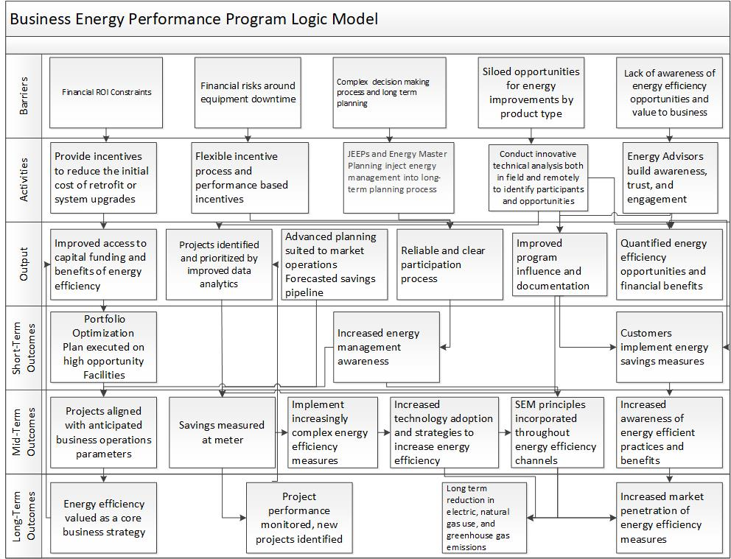

3. Process Flow chart

Custom:
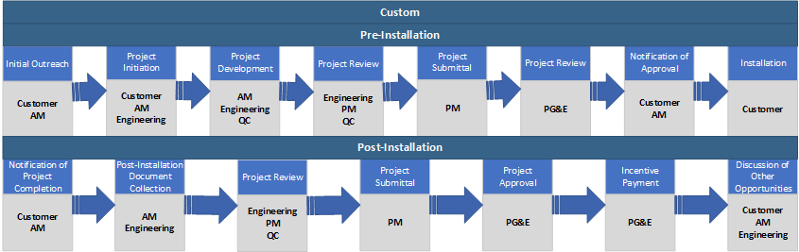
Deemed:
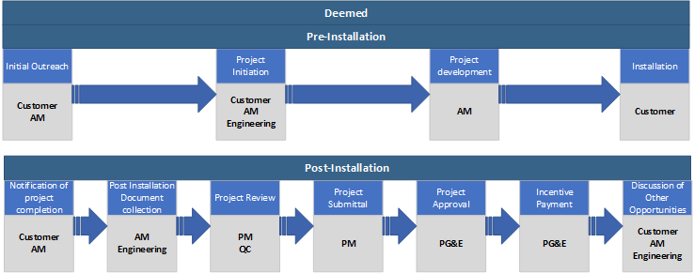

4. Incentive Tables, Workpapers, Software Tools

The Program’s incentive structure aligns with CPUC best practice guidance for performance-based programs while presenting understandable and manageable solutions for the broad group of customers this program will serve. Specifically, the Program aligns incentives with lifecycle savings, promoting increasing degrees of efficiency, considering barrier the variation of different customers. Custom projects will be incentivized at a lower dollar-per-savings rate to account for the benefit of technical assistance in the form of project identification, scoping, and modeling. Summary table below provides average incentive levels offered in the Program.

Incentive Rates | $/kW | $/kWh | $/therm
Deemed | $90 | $0.08 | $1.00
Custom | $150 | $0.14 | $1.43

The Program does not anticipate a significant amount of deemed measures from this sector and have therefore modeled the Program accordingly. However, to the Program will support current and future deemed workpapers aligned with market needs to better serve PG&E customers. Deemed measures included in our Program are ready for implementation at the time of program launch, with the following qualifications:
- SWWH017-01 Hot Water Pipe Insulation, Nonresidential (Rev 1): DEER http://www.deeresources.net/workpapers

5. Quantitative Program Targets

The targets provided herein are best estimates, but nonetheless are forecasts contingent on many factors.

Category | 2021 | 2022 | 2023 | Total
# of Projects | 54 | 81 | 99 | 234

6. Diagram of Program

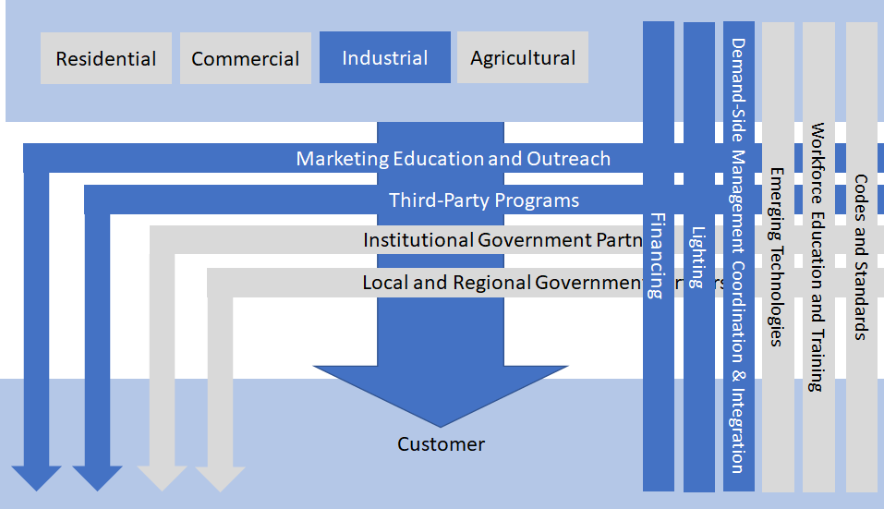

7. Evaluation, Measurement & Verification (EM&V)

The Program will track and manage program data using our Salesforce-enabled platform, currently used to support energy efficiency programs for more than 50 utilities nationwide. The Program’s platform will benefit all aspects of Program delivery and evaluation activity, including:
- Existing integration with PG&E’s Energy Insight platform to enable pipeline sharing and easy access to portfolio-wide data
- Project tracking from initial site assessments to completion and, if applicable, performance monitoring – informing all program stakeholder communication and providing a centralized foundation for program tracking
- Flexible reporting that unlocks meaningful data such as weekly, monthly and year-to-date production totals, daily pipeline volume/status and wait time, customer contact information, customer acquisition at each stage (work in progress, backlog and cancelled pending), participation by measure, QA/QC performance, and customer satisfaction scores
- Secure, role-based access that improves data integrity, reduces errors and prevents unauthorized access
Program’s Engineering QA/Policy team regularly tracks and communicates policy changes across the company using consistent methods. This regular dissemination of CPUC, utility, and CLEAResult-approved protocol empowers our staff to make concise and fiscally appropriate judgements when evaluating opportunities. Prior to investment of significant time or capital, potential projects receive high-level evaluation by members of the Engineering QA/Policy team. This “pass/fail” method allows the Program to concentrate efforts on opportunities that can overcome regulatory hurdles and garner cost-effective savings. These internal performance analysis during deployment supports evaluation criteria and compliance.
Upon a project officially being selected for advancement, data collection and measurement activities ensue with initial outlining of appropriate measure and baseline information. The following activities will be gathered or estimated for baseline, industry/code/customer standard practice, and proposed energy efficient equipment:
- Equipment specifications including estimated useful life (EUL) and remaining useful life (RUL).
- Energy consumption (source type, units of quantity) and hours of operation.
- Review on-site generation where applicable to determine eligible energy savings that reduce energy supplied from the grid.
- Measure costs to determine eligible costs (material cost of equipment, operation & maintenance, removal/demolition, permitting, freight, project development).
- Other data and factors (weather, process temperatures, production) that may impact the energy usage.
Verification and internal review of the information collected shall verify the measure eligibility:
- Does not overlap with other incentive programs
- Exceeds baseline energy performance and regressive baseline is not used
- Proposed equipment provides equivalent level of service
- Incremental measure cost is greater than zero
- Custom project EUL must be greater than simple payback period
- Installations adhere to federal, state, and local laws, building codes, manufacturer’s specifications, and permits
- Applicable measure cost basis used for selected measure application type
- Fuel substitution criteria and test is passed where applicable
To ensure that energy savings persist and meets program metrics, the following steps are imbedded in the program:
- Confirmation that existing equipment is decommissioned and removed from site, or exception granted by PA prior to installation for Accelerated Replacement (AR) and Normal Replacement (NR) measures.
- Confirmation of installation of new equipment or controls for AR, NR, Add-On Equipment (AOE), and New Construction (NC) measures.
- Repair and re-deployment of existing equipment conducted as a Behavioral, Retro-commissioning, and Operational (BRO) measure.
- Confirmation of permanent installation of the AR, NR, AOE, NC measures such that the energy savings persist over the measure life.

8. Normalized metered energy consumption (NMEC)
Not applicable.

