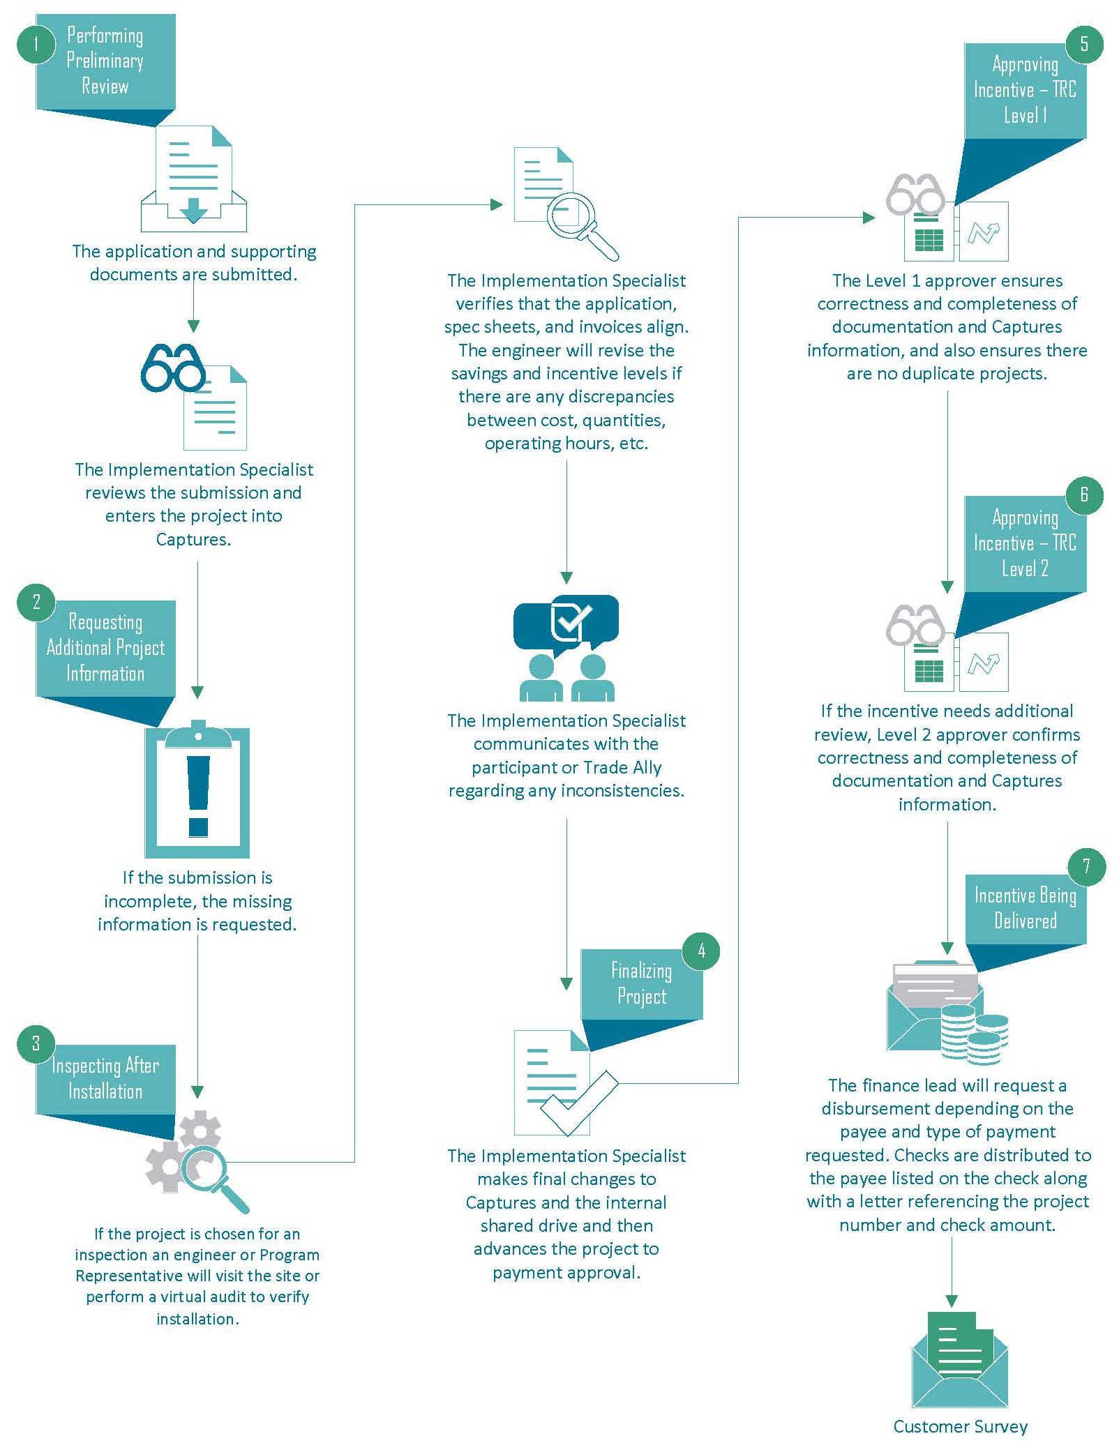
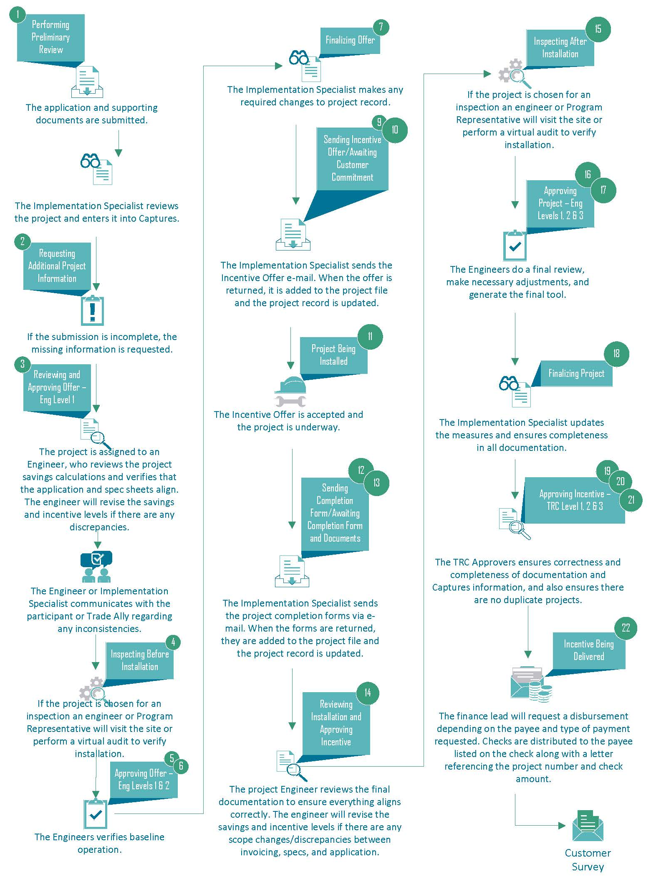
AESAP Program Deemed Process Flow Chart AESAP Program Custom Process Flow

AESAP Program OBF Process Flow
