- Program Name: Community Language Efficiency Outreach – Direct Install (CLEO-DI)
Program ID Number: 5660058827
Program type: Third Party Residential Program.

- Projected Program Budget Table

Table 1

Gas Budget By Category
Cost Category* | 2020 | 2021 | 2022 | Total | % of Total Budget
Administration | $42,200 | $38,400 | $39,400 | $120,000 | 6.0%
Marketing | $25,400 | $24,800 | $24,800 | $75,000 | 4.0%
Direct Implementation - Non-Incentive | $257,700 | $257,700 | 257,700 | $773,100 | 40.0%
Direct Implementation – Incentive | $327,050 | $327,050 | $327,050 | $981,150 | 50%
Total Budget | $652,350 | $647,950 | $648,950 | $1,949,250 | 100%

- Program Description

- Describe program

CLEO-DI will provide residential in-language, Marketing, Education and Outreach (“ME&O”) and Direct install of residential energy efficiency measures, targeting the HTR/DAC Chinese, Vietnamese, Korean, Hispanic and other ethnic communities of LA and Orange Counties and areas mutually agreed upon by both parties.

Contractor will perform the following activities on behalf of the Program:

The program will provide ME&O and enroll customers via hosted booths and in-language seminars at community events and through targeted marketing campaigns. CLEO’s in-language web site cleosave.com will provide program information and enroll customers. To ensure cost efficiencies, CLEO will leverage its relationship with the community and proven community channels. In-Language installers will provide direct install to the customers.

The program targets the hard-to-reach and disadvantaged residential communities with an in-language ME&O and Direct Install offering. The HTR/DAC communities require a focused and targeted in-language, culturally sensitive and innovative marketing to enroll them for direct install programs. Colorful in-language brochures with in-language marketing personnel, as well as a toll-free, in-language support line will ensure that customers can access the EE offerings comfortably in their language of preference. Creative outreach and Channel marketing strategies will build trust and bolster community participation. In-language installers will conduct walk-through of EE measures and educate customers about available EE programs.

Contractor will install all or a combination of the measures mentioned below based on the proper applicability of the measure for the residence. Contractor trained and experienced installers will conduct all installs. All installers will be hired from each HTR/DAC community. The program will target 750 homes in 2020, 750 in 2021, 750 in 2022.

Direct Implementation Measures may include:
- Smart Thermostat
- Tub Spout Diverters
- Low-Flow Showerheads
- Kitchen and Bathroom Faucet Aerators
- Hot Water Pipe Sleeve
- Water Heater installation
- Ways to Save online tool support
- EE kit fulfillment
- Additional measures that leverage outside funding to be agreed upon by both parties

Direct Implementation Activities:
- In-Language EE Seminars
- In-Language Community Booths
- Schools Outreach
- Church, FBO and Senior Center Outreach
- Local Governments and CBO’s Partnership events
- Installers and in-language marketing staff will canvass door-to-door with in-language personnel to clearly explain the program and enroll customers
- Publish articles in local City Newsletters articles, encouraging residents to participate

- Statement of Problem and program solutions to overcome the problem

CLEO-DI Program seeks to overcome the English as a second language market barrier in targeting hard-to-reach, low- and medium-income customers. The Program strategy is unique in that it is a 100% in-language strategy, which serves In 2020-2023 the program will target the Vietnamese, Indian, Chinese and Korean and will also expand the Program to target the Indian, Hispanic (Spanish speaking) and the hard-to-reach, low and medium income customers in the African American Communities.

- Program goals, strategies and measurable objectives

The Program will offer a total of 100 in-language seminars, 5,000 short 5-minute, Home Energy Efficiency Surveys (HEES), 50 community booths, 300 375 radio ads, 400 newspaper advertisements, 90 television advertisements, an in-language toll free hotline, outreach with schools, outreach with local community houses of worship, cities and Community Based Organizations (CBO’s). In addition, CLEO will create and update an effective web presence and provide attractive in-language promotional materials and energy efficiency information.

Deliverable | 2021 | 2022 | 2023 | Total
Gross Therm Savings, first year annualized | 31,628 | 31,628 | 31,628 | 94,884
Net Therm Savings, first year annualized | 23,098 | 23,098 | 23,098 | 69,294
Gallons Saved (if applicable) | 2,025,000 | 2,025,000 | 2,025,000 | 6,075,000
Non-resource Deliverable(s), if applicable:
(Sales Consultations)
Community Seminars | 4 | 4 | 4 | 12
Community Booths | 30 | 30 | 30 | 90
Schools | 10 | 10 | 10 | 30
Assumed Program Launch Date August 1, 2020

Deliverable | 2021 | 2022 | 2023 | Total
Gross Therm Savings, first year annualized | 31,628 | 31,628 | 31,628 | 94,884
Net Therm Savings, first year annualized | 23,098 | 23,098 | 23,098 | 69,294
Gallons Saved (if applicable) | 2,025,000 | 2,025,000 | 2,025,000 | 6,075,000
Non-resource Deliverable(s), if applicable:
(Sales Consultations)
Community Seminars | 4 | 4 | 4 | 12
Community Booths | 30 | 30 | 30 | 90
Schools | 10 | 10 | 10 | 30
Assumed Program Launch Date August 1, 2020

- Target Audience/s

CLEO will target 50% of the SoCalGas’ residential customers with its marketing outreach. However, for optimum results, the program will focus on areas with large numbers of Vietnamese, Indian, Chinese, Korean, Hispanic and African American (VICK-HA) residents.

- Identify if and how this program will provide any elements of Workforce

The Community Language Efficiency Outreach Program will work actively with churches, schools and cities for program outreach and delivery strategies. In addition, by targeting ethnic communities, the Program seeks to elicit greater participation from and increase energy awareness in hard-to-reach areas.

- Program Rationale and Expected Outcome

The program will provide ME&O and enroll customers via hosted booths and in-language seminars at community events and through targeted marketing campaigns. CLEO’s in-language web site cleosave.com will provide program information and enroll customers. To ensure cost efficiencies, CLEO will leverage its relationship with the community and proven community channels. In-Language installers will provide direct install to the customers.

- Program Design to Overcome Barriers

The following table provides descriptions of the barriers that Program seeks to address and the solutions the Program proposes to overcome the barrier.

Barrier | Solution
Lack of consumer information about energy efficiency benefits | The Program addresses this barrier by seeking to provide Program information in customers’ native languages and distributing information very widely.
Lack of financing for energy efficiency improvements. | Program provides customers information about SoCalGas incentive programs, thereby improving their access to these resources.
Lack of a viable and reliable resources to educate and inform | Program holds educational seminars and provides services at schools in target portions of service territory.
Residential
Language: Primary language spoken is other than English | Program addresses this issue directly by translating energy efficiency materials into non-English languages and providing services with customer service personnel who speak the same language as target customers.
Income: Income levels less than 400% of federal poverty guidelines | Many of the Program’s target customers are income qualifying.
Housing Type: Multi-family and mobile home tenants | Many of Program’s target customers are in multi-family housing units. The Program establishes mechanisms to ensure that these customers receive its energy efficiency information benefits.
Geographic: Residents of areas other than the San Francisco Bay Area, San Diego area, Los Angeles Basin or Sacramento, | Program targets traditionally underserved portions of SoCalGas’s service territory.

- Quantitative Program Targets

Table 4

Deliverable | 2021 | 2022 | 2023 | Total
Community Seminars | 4 | 4 | 4 | 12
Community Booths | 30 | 30 | 30 | 90
Schools | 10 | 10 | 10 | 30
Assumed Program Launch Date August 1, 2020

Measure # | Measure Description | Total Qty Installed  (3 years)
1 | Kitchen Aerator (min 1.5 gpm) | 900
2 | Bathroom Aerator (min 1.0 gpm) | 3975
3 | Low-Flow Showerhead (min 1.5 gpm) | 2700
4 | ENERGY STAR certified Residential Smart Thermostat | 2400
5 | Hot Water Pipe Wrap | 660
6 | Tub Spout Diverter Valve with Thermostatic Showerhead | 1500
7 | Water Heater installation (must be ENERGY STAR certified water heater, 40 gal, min UEF>=0.64) | 300
8 | EE kit event hand out | 1500

- Program Implementation

The Program will encourage customers to participate in SoCalGas’s programs and services, and will coordinate with the local water agencies and will promote increased awareness for customers to understand the structure and opportunities for energy efficiency. Synergies will be leveraged to cost effectively disseminate efficiency knowledge and training.

- Program delivery mechanisms

The program targets the hard-to-reach and disadvantaged residential communities with an in-language ME&O and Direct Install offering. The HTR/DAC communities require a focused and targeted in-language, culturally sensitive and innovative marketing to enroll them for direct install programs. Colorful in-language brochures with in-language marketing personnel, as well as a toll-free, in-language support line will ensure that customers can access the EE offerings comfortably in their language of preference. Creative outreach and Channel marketing strategies will build trust and bolster community participation. In-language installers will conduct walk-through of EE measures and educate customers about available EE programs.

Contractor will install all or a combination of the measures mentioned below based on the proper applicability of the measure for the residence. Contractor trained and experienced installers will conduct all installs. All installers will be hired from each HTR/DAC community. The program will target 750 homes in 2020, 750 in 2021, 750 in 2022.

Direct Implementation Measures may include:
- Smart Thermostat
- Tub Spout Diverters
- Low-Flow Showerheads
- Kitchen and Bathroom Faucet Aerators
- Hot Water Pipe Sleeve
- Water Heater installation
- Ways to Save online tool support
- EE kit fulfillment
- Additional measures that leverage outside funding to be agreed upon by both parties

Direct Implementation Activities:
- In-Language EE Seminars
- In-Language Community Booths
- Schools Outreach
- Church, FBO and Senior Center Outreach
- Local Governments and CBO’s Partnership events
- Installers and in-language marketing staff will canvass door-to-door with in-language personnel to clearly explain the program and enroll customers
- Publish articles in local City Newsletters articles, encouraging residents to participate

- Marketing Plan

    - market research and/or segmentation
This is not applicable to this program.

    - Proposed behavior change theories application, if available
This is not applicable to this program.

    - Proposed target audience/s, if applicable both primary and secondary
The proposed target audiences are VICK-HA (Vietnamese, Indian, Chinese and Korean – Hispanic and African American) residential customers.

    - Message development process, including pre-tests
This is not applicable to this program.

    - Delivery channels, if applicable include public relations and earned media activities

CLEO Marketing activities are required to generate program awareness and to facilitate program participation. Colorful community booths and classroom style in-language seminars will provide and educate customers on energy efficiency programs and utility rebates. There will also be an updated web presence at www.cleosave.com, which will provide targeted customers with program information and program sign-ups. The website will also provide an in-language educational platform for energy efficiency and demand-side management. Where available the program will leverage synergies with other programs including Residential and Partnership Programs.

Community Marketing Activities:
CLEO Community activities represent the implementation aspects of the program. These activities seek to enrich the target audience by providing the tangibility and presence to the communities served. Implementation activities include:

In-Language Seminars – The objective of In-language Seminars will be to provide a classroom style form to empower residential customers to conserve resources by teaching them simple ways of savings Gas, Electricity and Water. This strategy will align itself with a goal of the Workforce Education and Training Strategic Plan to ensure that minority, low income and disadvantaged communities fully participate in education programs by providing modules that will seek to encourage interest toward employment in the energy efficiency industry. Seminars will also be used to promote other program offerings and direct install.

Community Booths – CLEO-DI, will continue participating in prominent ethnic cultural booths such as the ‘Chinese New Year’ and ‘Harvest Moon Festivals’. The program will coordinate with SoCalGas to avoid any overlap. Community Booths will also be promote the Direct Install.

Schools Outreach – In 2020 - 2023 the CLEO program will expand its schools outreach efforts by providing a comprehensive schools outreach strategy. In addition to the continuing ‘Energy-Artist’ contest with winners from partnering schools awarded prizes and recognition the program will also introduce the Direct Install program, to encourage parental participation. Outreach efforts will also include coordination with local school boards and will also target Adult Education (ESL) educational centers.

Faith Based Organizations (FBO’s) and Adult Day Care Center Outreach - Local community FBO’s and religious forums form the backbone of ethnic community. FBO’s also provide a forum for Community events and an excellent platform to market and encourage energy efficiency. CLEO will cultivate and add to the existing relationships with churches and Adult Day Care centers to effectively cultivate program participation and promote energy conservation. This outreach mechanism will allow the CLEO-DI Program to expand outreach to the Hispanic and African American Communities in 2020 - 2023.

Community / City Partnership and Outreach – This outreach strategy will build upon existing relationships with the cities of Monterey Park, San Gabriel, Alhambra, Walnut, Diamond Bar and others to promote energy efficiency in the community. CLEO-DI will participate in City Earth Day events to further promote energy efficiency in the community. CLEO will coordinate with SoCalGas’ Partnership Programs.

    - Plans for developing message concepts
This is not applicable to this program.

    - Implementation timeline
This is not applicable to this program.

Program Theory and Design: Program understands and incorporates into marketing local market conditions, maintains program flexibility to response to changes in market and other factors and defines and locates hard-to-reach customers and targets programs accordingly.

Program Implementation – Participation Process: The Program utilizes participation strategies that are multi-pronged and inclusive and keeps participation simple.

- Innovation
The 100% in-language aspect of CLEO-DI separates it from any other outreach effort, and provides a level of understanding to the target population. Many of the program participants have language barriers and cannot be reached through any outreach effort that is delivered in another language.

- Integrated/coordinated Demand Side Management
The Program will seek to integrate information relevant to other SoCalGas’ program offerings and coordinate messages to maximize educational opportunities.

- Integration across resource types (energy, water, air quality, etc
CLEO provides effective integration of energy (electric and gas), water and recycling with its home energy direct install. Promoting energy efficiency effectively to the in-language residential customer presents challenges but provides opportunities to truly interact with this hard-to-reach customer on a personal level. The key barrier to energy efficiency continues to revolve around the lack of information or awareness of specific measures and practices which is compounded when a language barrier exists.

- Pilots
CLEO does not have any Pilots. In 2020 – 2023, CLEO will extend the program to all residential customers of SoCalGas. New inclusions will be municipal utility service areas of Los Angeles, Pasadena, Burbank, Glendale, Anaheim and Riverside. CLEO will leverage local municipal utilities to form partnerships

- EM&V
The utilities are proposing to work with the Energy Division to develop and submit a comprehensive EM&V Plan for 2020 - 2023 after the program implementation plans are filed. This will include process evaluations and other program-specific studies within the context of broader utility and Energy Division studies. More detailed plans for process evaluation and other program-specific evaluation efforts cannot be developed until after the final program design is approved by the CPUC and in many cases after program implementation has begun, since plans need to be based on identified program design and implementation issues.

- Diagram of Program
No specific program diagram for this third party program has been developed. Any program linkages are discussed in Section 6. However, provided below is a diagram of the Program’s implementation approach and marketing strategy.

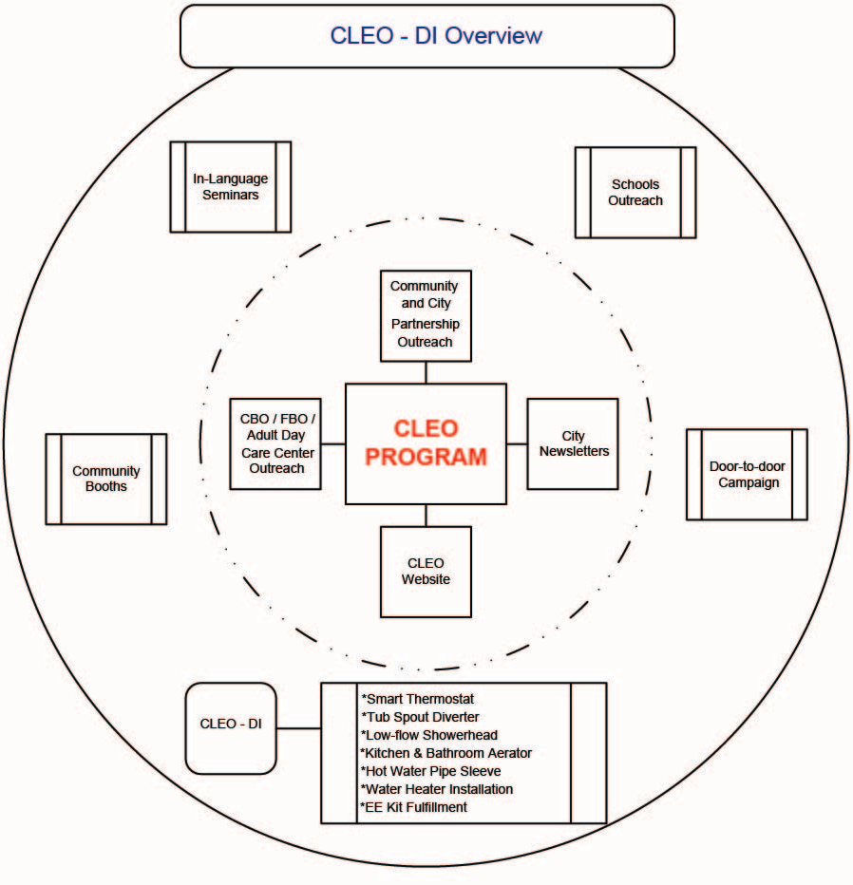

- Program Logic Model
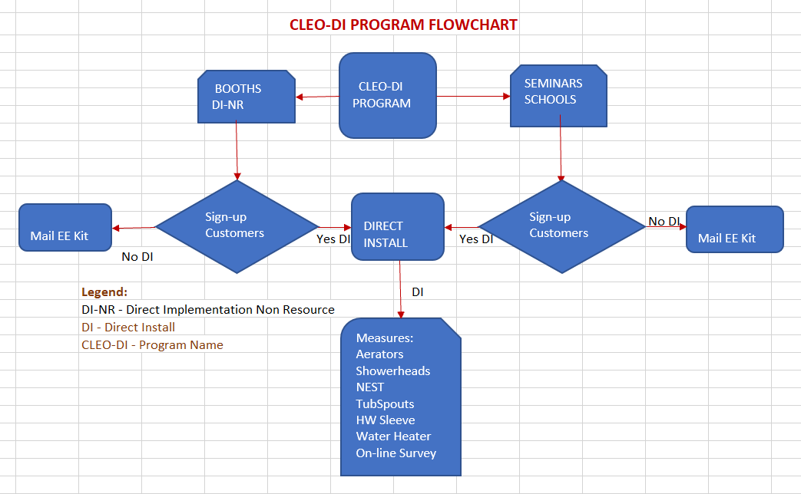

- DBE Requirement:

DBE GOAL FORMS

- Agreement Title: ____Community Language Efficiency Outreach – Direct Install (CLEO-DI)

Agreement No: 5660058827 Program: _CLEO-DI

Term of Agreement: ___2020-2023

Brief Description of Scope of Contract
CLEO-DI will provide residential in-language, Marketing, Education and Outreach (“ME&O”) and Direct install of residential energy efficiency measures, targeting the HTR/DAC Chinese, Vietnamese, Korean, Hispanic and other ethnic communities of LA and Orange Counties and areas mutually agreed upon by both parties.

GES is a 100% owned and certified by CPUC and State as a MBE and SBE. All staff and customers served are with disadvantaged communities.

- Contact information for person(s) responsible for Contractor’s monthly DBE reporting:

Name: Basu Mukherjee, President

Total dollar value of Work/Agreement: $1,949,250

Total dollar and percentage of Work planned with DBEs* (contracting and subcontracting):
$1,949,250 100%

Estimated percentage breakdown:
MBEs (minorities, male and female) $__________ _________%

WBEs (non-minority female) $__________ _________%

SDVBEs (service disabled veteran) $____________ ___________%

LGBT (lesbian, gay, bisexual, transgender) $____________ ___________% *NOTE: The estimated total dollars will be adjusted using the above percentages for any change in Agreement value.
By signing below, Contractor represents and warrants that: a) Contractor shall maintain all necessary documents and records to demonstrate efforts to achieve the above DBE goals, b) Contractor is responsible for identifying, soliciting, and qualifying appropriate certified DBE subcontractors to the extent necessary to meet Contractor’s DBE goal, and c) the above information is true and correct to the best of its knowledge.

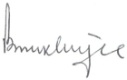
Signature: ______________

Name and Title: ___Basu Mukherjee, President

Contractor Name: __Global Energy Services, Inc.

Contact Info (email/phone number): __Basu@gesusa.org / (909) 860-5300

Date: _July 22, 2020

Definition of Table 1 Column Headings: Total Budget is the sum of all other columns presented here Total Administrative Cost includes all Managerial and Clerical Labor, Human Resource Support and Development, Travel and Conference Fees, and General and Administrative Overhead (labor and materials). Total Direct Implementation – includes all financial incentives used to promote participation in a program and the cost of all direct labor, installation and service labor, hardware and materials, and rebate processing and inspection used to promote participation in a program. Integrated Budget Allocated to Other Programs includes budget utilized to coordinate with other EE, DR, or DG programs. Market Research: e.g. customer segmentation, message pre-tests, behavior, baselines, if available. Collateral: information produced for customer e.g. brochures, bill inserts, advertisements (TV, radio, print, internet), event displays, etc Delivery: delivery channels, e.g. direct mail, mass media (print, radio, TV, internet), outdoor, etc Total Budget is the sum of all other columns presented here Definition of Sub-program: a “sub-program” of a program has a specific title: targets, budget, unique delivery or marketing approach not used across the entire program, if no sub-program exists, please leave blank.
To be provided for overall program (explaining how sub-programs form a coherent plan) and for each sub-program
kWh and therm values are estimated using DEER/deemed values; water savings are estimated.
kWh and therm values are estimated using DEER/deemed values; water savings are estimated.
To be provided for each program and sub-program in PIP.
kWh and therm values are estimated using DEER/deemed values; water savings are estimated.

