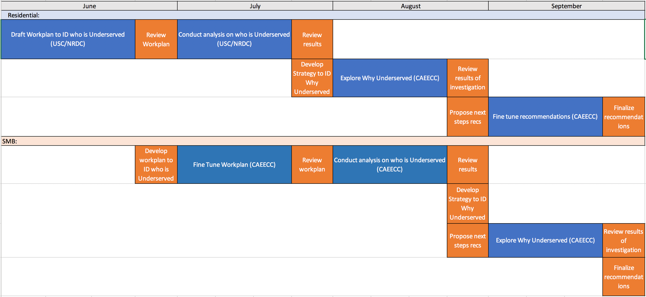
Draft Underserved Working Group Multi-Meeting Strategy

Mtg 1 (June):
- Residential:
  - Review and revise USC/NRDC proposed workplan to identify underserved residential customers
- SMB:
- Develop proposed workplan to identify underserved SMB customers

Mtg 2 (July):
- Residential:
  - Review results of data analysis to identify underserved residential customers
  - Develop strategy for follow-up exploration into likely causes for being underserved (e.g. HTR definition, or other reasons)
- SMB:
  - Review and revise proposed workplan to identify underserved SMB customers, and identify sub-working group members to conduct analysis

Mtg 3 (August):
- Residential:
  - Review results of exploration into likely causes for being underserved
  - Develop next step recommendations including:
    - Forums (including CAEECC) and processes to develop appropriate strategy or strategies for addressing each underserved customer segment, and
    - Metrics to set goals and measure progress.
- SMB:
  - Review results of data analysis to identify underserved SMB customers
  - Develop strategy for follow-up exploration into likely causes for being underserved; and
  - Develop next step recommendations including:
    - Forums (including CAEECC) and processes to develop appropriate strategy or strategies for addressing each underserved customer segment, and
    - Metrics to set goals and measure progress.

Mtg 4 (September):
- Residential:
  - Finalize recommendations
- SMB
  - Review results of exploration into likely causes for being underserved
  - Review (and finalize) draft next step recommendations
- Next Steps:
  - Process for finalizing report to Commission including recommendations and supporting research

