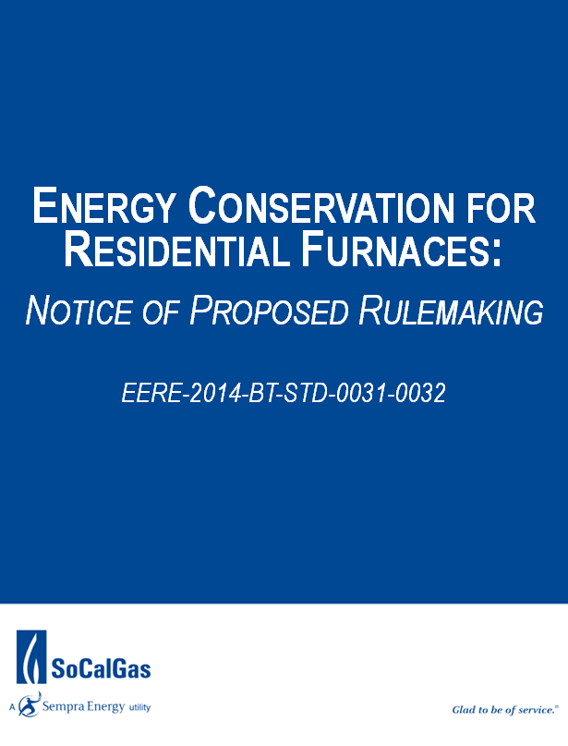
Table of Contents:

- UPDATE - AGA Board Meeting (October 12, 2015)………….…………………….……………. 3
Legislative Update
Results from Comments to NOPR
Notice of Data Availability
SoCalGas’ Planned Action on the NODA
- Attachments …………………………………………………………………………………………………… 7
FOR REFERENCE: DOE Furnace Rule-AGA Board Book
Notice of Data Availability
Revised Summary of AGA Comments for Furnace Rule
AGA Draft Comments on Notice of Data Availability

I. UPDATE – AGA Board Meeting (October 14, 2015)

AGA Board Agenda Items Requiring Response:

Action Requested
The Board is asked to advise whether AGA should attempt to negotiate a
compromise that preserves non-condensing furnace options for many, but not all
consumers; or, if AGA should instead focus on a possible court challenge.

- SoCalGas would like the AGA to attempt to negotiate a compromise that preserves a minimum standard threshold for non-condensing furnaces at 65 KBtu/h
- SoCalGas understands the potential limitations for successful litigation but does not oppose the AGA continuing to prepare for that eventuality considering the potential to not reach a consensus on furnace size among the stakeholder group

Since filing comments to the Notice of Proposed Rulemaking, the following actions have taken place:

Legislative Update
The American Gas Association (AGA) and the SRE Washington office are pursuing a legislative fix to the Department of Energy’s (DOE) furnace rulemaking. The House Energy & Commerce Committee recently passed out of committee a bill that prohibits the DOE from issuing a final rule until July 2016. It is expected that the bill will come to the floor of the House of Representatives sometime in the next few weeks and it should have the votes to pass in the Republican majority House.
The Senate Energy and Natural Resource Committee has also passed a bill out of committee that prohibits DOE from moving forward with the rule without a stakeholder conference to evaluate if the furnace rule is economically justifiable. Although the Senate bill passed out of committee with bipartisan support, it is unclear when or if the bill will be brought to the floor of the Senate this year. Therefore, despite success in addressing the furnace rule in both houses of Congress, the uncertainty of final passage by both houses and a reconciliation of any differences before December is unlikely. We expect the DOE to issue a final rule in December prior to the President’s trip to Paris for climate talks.
Results from Comments to NOPR (copy of AGA document attached)
This Notice of Proposed Rulemaking generated a significant amount of attention and the predominant responses were in opposition to the action. Below is an excerpt from a summary of the responses received as prepared by AGA:

Those in favor of the NOPR were generally environmental and energy efficiency-focused groups, including the American Council for an Energy Efficient Economy (ACEEE), the Alliance to Save Energy, California Energy Commission, Consumer Federation of America, Natural Resource Defense Council (NRDC), Northeast Energy Efficiency Partnerships, and Pacific Gas & Electric (PG&E). These groups were extremely supportive of raising the AFUE to 92 percent as proposed, arguing that DOE has demonstrated in their analysis that this standard has already been found to be technologically feasible and cost-effective. While achieving the maximum level of energy efficiency is the prominent aim, supporters, such as Northeast Energy Efficiency Partnerships, also argued that the NOPR will assist low income consumers by reducing monthly utility bills. California-based groups, such as the California Energy Commission and PG&E noted that states were not able to institute their own appliance standards on efficiency and NOx emissions, and needed DOE to act to meet their state’s statutory requirements.

Many critical submissions focused on the negative impact the rule would have on ratepayers, especially low-income consumers. The negative consequence to consumers associated with fuel switching prompted by a condensing standard was another concern shared by almost all natural gas stakeholders, such as Washington Gas and Light, New Jersey Natural Gas and SoCalGas. SoCalGas’ analysis reflected that all customers in SoCalGas’ service territory would suffer a “net cost” rather than a “net benefit” with the proposed rule. This is particularly concerning considering that nearly 33% of California residents fall below the poverty line. These lower income consumers will bear a higher burden than the remaining consumers should this rule be enacted. Additionally, due to the warm climate in California, the simple payback on installation of the equipment proposed in this rulemaking would exceed the stated 21.5 year life of the equipment. SoCalGas’ analysis also contends that government intervention is unnecessary because the condensing furnace market has moved substantially toward the proposed 92% AFUE level in the appropriate markets without it being mandated by the standard. Many groups, such as the American Energy Alliance, discussed the environmental impacts of fuel switching, arguing that the increased use of electric heating systems would cause an increase in greenhouse gas emissions. Advocates of multifamily structures, such as the National Multifamily Housing Council, raised concerns regarding the high cost involved in retrofitting multifamily homes and row houses with condensing furnaces.

Manufacturers and contractors, such as the Air Conditioning Contractors of America, raised concerns over the more technical aspects of the rule, including flaws found in methodology, the failure to accurately estimate costs of installation, updated ventilation, the finalization of test procedures, and the life expectancy of the furnaces.

Noteworthy was the fact that comments were submitted by a consortium of United States House of Representatives -123 Congressional Members joined to submit their opposition to this rulemaking:

United States House of Representatives Congressman Brooks et al.: Brooks et al. raised concerns regarding the ability of low- or fixed-income households to pay for the installation of more efficient natural gas heating systems. The inability to pay for installation, according to Brooks, would result in the use of less efficient electric heating systems, increasing greenhouse gas emissions. Brooks et al. stated that the proposed rule would force citizens to pay thousands for new installations or abandon natural gas use altogether. Brooks et al. recommended that DOE establish separate product classes with respective efficiency standards for condensing and non-condensing furnaces to remove the financial burden from low-income citizens.
Notice of Data Availability Summary
On September 14, 2015, the Department of Energy (DOE) published a Notice of Data Availability (NODA), 80 Fed. Reg. 55038, and released two spreadsheets, one on consumer impacts (life-cycle costs/payback periods) and one on national impacts (national energy savings and net present value of national benefits).
The key aspect of this analysis is that only large furnaces would need to use condensing technology to meet the standard. Therefore residential buildings installing a small furnace would not need to incur the costs associated with installing a condensing furnace.
Table II.1—Potential Standard Level Combinations Analyzed for Large and Small Furnaces
Furnace size | Annual fuel utilization efficiency (%)
Large | 90 | 92 | 95 | 98
Small | 80 | 80 | 80 | 80

This NODA analysis used the same sample of residential furnace consumers as the March 2015 NOPR. Each sample household was assigned a furnace size (in terms of input capacity) based on a number of features. The share of households that would install a small furnace depends on how “small furnace” is defined in terms of input capacity. For this analysis, DOE considered the following small furnace definitions: ≤45 kBtu/hour, ≤50 kBtu/hour, ≤55 kBtu/hour, ≤60 kBtu/hour, and ≤65 kBtu/hour. In each case, large furnaces would be defined as all sizes above the given thresholds. The share of households that would install a furnace meeting a small furnace standard rises as the size cutoff in the small furnace definition increases.

Table II.2—Share of Sample Households by Furnace Size
Furnace size | Small furnace definition | ≤45 kBtu/hour | ≤50 kBtu/hour | ≤55 kBtu/hour | ≤60 kBtu/hour | ≤65 kBtu/hour
Large | 92 | 86 | 85 | 68 | 62
Small | 8 | 14 | 15 | 32 | 38
Total | 100 | 100 | 100 | 100 | 100

Comments have been requested to improve the analysis, as the simulation inputs were not changed to adequately address issues provided by many stakeholders.

SoCalGas’ Planned Action on the NODA
The AGA will be asking the BOD whether they should attempt to find a compromise on minimum threshold for the small furnace size with the key stakeholders to the rule (ACEEE, NRDC, Alliance to Save Energy, etc.). SoCalGas should encourage the AGA to seek that compromise however all information would indicate that a compromise is likely not to be achieved because of the significant divide in opinions on what that size should be. Nonetheless, SoCalGas believes an attempt should be made on behalf of our customers.

Because SoCalGas took a firm position and filed detailed comments to the issuance of the NOPR, it was decided that the company should also file equally firm comments regarding the NODA.

SoCalGas’ position is that although we applaud the DOE’s attempt to find a compromise option, our original concerns have not been addressed. This NODA proposes an option that seeks to address the economic impact to our customer and to some extent it achieves that. However, the DOE has not yet addressed the methodology flaws in the following areas:
- Method DOE used to determine the homes that would be impacted by the proposed rule
- Method DOE used in its fuel switching analysis
- Inaccuracies in various key input variables used in the DOE NOPR Life-Cycle Cost (LCC) Analysis
Regarding the intent of the NODA, which is to gain information on what size threshold would be acceptable for the smaller furnace size, SoCalGas would require a minimum of 65 KBtu/h as that minimum threshold in order to mitigate the negative impact to our customer.

II. Attachments

FOR REFERENCE:
DOE Furnace Rule-AGA Board Book
Notice of Data Availability | http://www.regulations.gov/#!documentDetail;D=EERE-2014-BT-STD-0031-0166
Revised Summary of AGA Comments for Furnace Rule

AGA Draft Comments on Notice of Data Availability

