***Summary***

***DOE LCC Analysis of Added Installation Cost for***

***Replacement Condensing Furnaces***

**Inclusion of Installation Cost Scenarios in LCC Analysis**

There is a concern that while the DOE condensing furnace standard is Life Cycle Cost (LCC) cost effective for the Nation and California, the impact of difficult and high installation cost furnace replacements has not been adequately accounted for in the LCC. The DOE methodology produced the data below from what is used by the LCC analysis. Starting at the point of replacing a noncondensing furnace the increased cost can be found in the “Average Increased Installation Cost” column. The “Percent of Annual Shipments” serves to put the results in perspective. The worst case is a cost of $1527 which is less than 1% of shipments and it is this case that the new technology reduces by over $500.



**Distribution of Installation Costs**

The DOE LCC analysis results generate 10,000 results which are organized into “bins” for plotting. The graph shows the distribution of occurrences is concentrated around the $627 average and that there is long “tail” of high cost installations. It is these few high cost cases that are memorable even though they represent a small fraction of cases. As discussed by DOE, these high incremental costs where driven by what is call “orphaned water heaters”. There are 14.4% of the annual furnaces shipped and installed that encounter this problem. In more than half of these cases (8.3 %) the water heater vent does not have to be sized but does need to be upgraded a dual wall vent pipe. The results of the LCC analysis are best understood by viewing the distribution in the chart below. 80% of cases have an incremental cost less than $1250 which is covered in the table above.

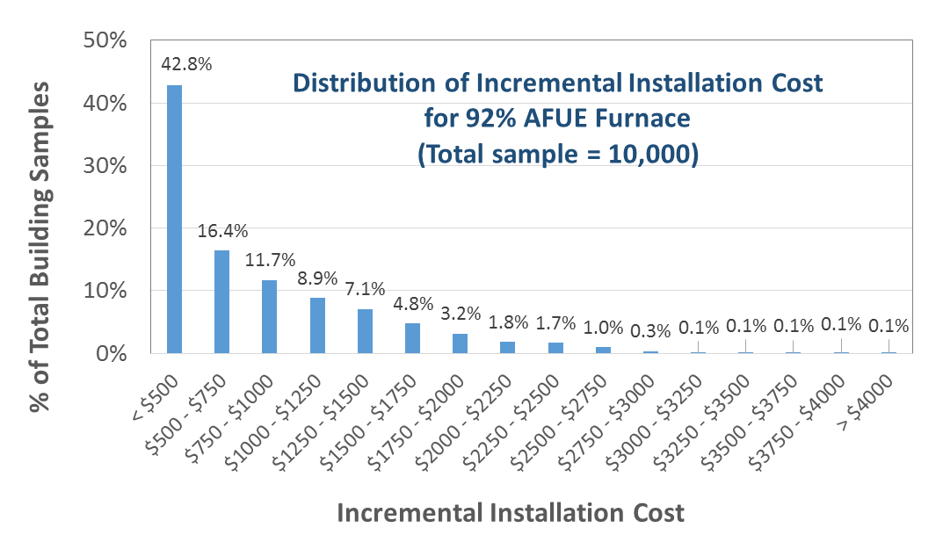

**Technology Solution for High Cost Installations**

An example of the creative and innovative response to condensing furnace standards comes from a major supplier of heating contractors. The case being considered is an attached dwelling, e.g. row house, in the Northeast with a masonry chimney into which the furnace and water heater are venting flue gases. The DuraVent technology provides for condensing furnace to be vented in a flexible stainless steel pipe that is located inside the atmospheric venting water heater flue.



As shown in the second illustration, the dual flue vent provides a solution to the need to line the existing masonry chimney. In discussions with Philadelphia Gas staff it was determined that they were visualizing that condensing furnaces required horizontal venting. They verified that the existing furnace and water heater vented through a masonry chimney that is straight and goes from the basement to the roof. DuraVent is the solution for these houses.





This reduction in installation cost of $453 when run through the LCC analysis results in negative LCCs becoming positive. The first column is the AFUE level where 92% is the DOE proposed level. The second is the LCC with DuraVent showing that all but the 90% levels are positive. The third column lists the LCC without DuraVent. In the 5 years till condensing furnaces become mandatory it can be predicted and other companies will develop and market solutions to compete with DuraVent and solve other high cost installation problems.

