PG&E Codes and standards Program

Supporting Information for PG&E Comments on DOE Residential Gas Furnace Rulemaking

June 30, 2015

Summary
The Department of Energy (DOE) life cycle cost (LCC) analysis method for residential furnaces, documented in the Notice of Proposed Rulemaking Technical Support Document (NOPR TSD), is based on a Monte Carlo analysis that considers the variability and uncertainty of all input parameters. This approach ensures all input possibilities associated with geographic, application, technical, and economic differences are included in the analysis along with their presentations in the market. Therefore, DOE’s LCC analysis results appropriately reflect the energy savings and cost effectiveness of different efficiency levels under consideration.
DOE’s analysis includes conservative assumptions for several input parameters, as explained in the following sections. We believe that these conservative assumptions are unnecessary and should be removed to more accurately model the costs and benefits of high efficiency furnaces. We provide LCC results using suggested revisions to the assumptions using the DOE LCC Crystal Ball analysis tool.
We support a national or regional standards based on TSL4 (Efficiency level 3 – AFUE 95%), because the DOE analysis shows that this standard level is cost effective on both national and regional basis. Results are even further cost effective with our modified results. Adopting a standard to dramatically reduce natural gas use is also critical for California to meet its NOx reduction target and US EPA’s smog control mandates.
Following are our suggestions for improvements to the DOE LCC analysis.

Make lower product markup assumptions
Section 2.7 of the TSD indicates that incremental markups are necessary for “the change in the manufacturer production cost of higher efficiency models to the change in the retailer or distributor sales price.” Section 6.1 states that “Because companies mark up the price at each point in the distribution channel, both baseline and incremental markups are dependent on the distribution channel [.]”
Once the furnace efficiency standard takes effect, manufacturer, wholesaler, and contractor costs for furnaces meeting the new requirements are likely to drop due economies of scales for manufacturers (and thereby wholesalers), and product familiarity for contractors. Yet, the incremental markups are based on current costs-of-good-sold, variant costs, and gross margins related to higher efficiency furnaces. These costs should be reflective of a scenario where the price point of the high efficiency furnace is essentially equivalent to the baseline furnace.
However, tables in Section 6.6.1 show very high incremental markups, as high as 69% in Alaska. These incremental markups are too conservative (high) in a market where manufacturers and contractors are competing to provide the best price for a furnace that meets the minimum federal standard, and should be excluded altogether by treating the new standard as the baseline.

Improve accuracy of market for vent system upgrade for orphaned water heater vents not accurately reflecting market status
We believe that DOE’s assumptions about vent system upgrades for orphaned waters can be improved for replacement, new owner, and new construction installations.
Reduce frequency assumptions for common-vented furnaces and water heaters: In particular, DOE analysis should include the effect of market penetration of high-efficiency water heaters by 2021, which would make many homes upgrade their vent for water heaters. For example, the 2009 DOE TSD on Residential Water Heaters, Direct Heating Equipment, and Pool Heaters, Figure 9.3.4, estimated that the market share for gas instantaneous water heaters could reach 28% based on a median projection. The new DOE water heater efficiency standards, which took effect in April 2015, effectively requires gas water heaters with more than 50 gallon storage capacity to be condensing water heaters. The California 2016 Title 24, effective in 2017, includes a prescriptive requirement of tankless (instantaneous) water heater for all new construction homes. To accommodate high-efficiency water heaters, new construction homes and many existing homes (including those with common vents for the furnace and water heater) will need to upgrade water heater vents. DOE’s analysis of vent system upgrade cost for orphaned water heaters was based market data collected before 2010. By 2021, the number of homes with a common venting system shared by NWGF and a natural vent water heater will be greatly reduced.
Consistent use of vent system source references: For existing NWGF replacement, DOE analysis relied on a 2010 consultant report to estimate costs of upgrading the vent system for orphaned water heaters. This consultant report was used to support the prior residential gas furnace standard development. However, as shown in the following table, DOE increased the frequencies for applying vent resizing costs without detailed explanation and any supporting data. These frequencies represent the percentages of existing homes where the common vent for the non-condensing furnace and water heater would be too large for the orphaned water heater. As explained above, we expect that increased market adoption of high-efficiency water heaters would further reduce these frequencies from the estimates provided in the consultant report. We recommend that DOE consistently use the results provided in the 2010 consultant report for frequencies to apply resizing orphaned water heater chimney or upgrading metal vent and include further reduction of these frequencies due to increased market adoption of high-efficiency water heaters.
Existing Non-Condensing Furnace | Replacement Furnace | Installation Requirement | Frequency of applying requirements
 |  |  | Consultant Report  Table 8-B.6.5 | Current Analysis Table 8D.2.19
Natural Draft | Condensing Furnace | Convert Water Heater from single wall to Type B vent Connector | 100% | 100%
Natural Draft | Condensing Furnace | Resizing Orphaned Water Heater Chimney or upgrading Metal Vent | 40% | 75%
Natural Draft or Fan Assisted | Condensing Furnace | Reline all unlined chimneys for Orphaned Water Heater | 100% | 100%
Fan Assisted | Condensing Furnace | Resizing Orphaned Water Heater Chimney or upgrading Metal Vent | 20% | 40%

Eliminate added costs for new owner installations common-vented with non-condensing water heaters: For new owner of condensing NWGFs, DOE included a common venting adder of $956 for all new owner installations planned to be commonly vented with non-condensing design option (Table 8D.2.27), which was assumed to represent 45% of the new owners. This adder is unnecessary. Homes in this category do not have a furnace, and therefore do not have an existing common vent for the furnace and water heater. Adding a dedicated vent for the new condensing NWGF does not affect the existing vent for the water heater and, therefore, does not trigger any vent upgrade requirement for the existing water heater. This common venting adder should be removed from the LCC analysis.
Reduce the frequency of common-vented new construction homes: DOE assumed that 44% of the new construction homes planned to have a common venting system for non-condensing NWGF and water heater as the baseline design option (Table 8D.2.28). As we indicated above, this assumption does not properly reflect the market trend of increased adoption of high-efficiency water heaters, especially for new construction home. In California, due to the 2016 Title 24 building standards, all new construction homes would have tankless water heater or those with equivalent or better efficiency by 2021. Therefore, this cost adder should not be applicable to California new construction homes. According, the applicable percentage nationwide would reduce from 44% to 40%, as California represents about 10% of the national NWGF shipment). Assuming other states will reduce the market share of non-condensing storage water heaters by 30%, the applicable nationwide market share for the common venting adder would be 28%..

Include learning curve effects on product price trends
The NOPR TSD section 8A.4 states the product price trends are set to decrease due to technology learning, which results in a decline in the cost of producing a given product as firms accumulate experience with the technology. However, when using the DOE LCC tool it appears that the learning rate impacting product price was instead set to “No Learning (Constant).” Section 8.2.1 states that a decreasing learning factor of 0.937 was applied to total consumer price, but the spreadsheet settings and results indicate otherwise. Please provide clarification for the learning factor used.

LCC analysis summary
We ran 10,000 trials using the DOE’s LCC tool with modified assumptions as described above, namely:
- Setting incremental markups set to equal 1
- Using consultant report frequencies, setting new-owner common-vent installations to 0%, and setting common-vented new construction homes to 28%
- Setting decreasing product price trends to include learning
- With 1, 2, and 3 combined
LCC analysis was performed for the entire U.S., Northern U.S., Southern U.S., and California.
Original Results
NWGF Efficiency Level | U.S. |  | Northern U.S. |  | Southern U.S. |  | California Only
 | LCC | LCC Savings | LCC | LCC Savings | LCC | LCC Savings | LCC | LCC Savings
0 - NWGF 80%
1 - NWGF 90%
2 - NWGF 92%
3 - NWGF 95%
4 - NWGF 98%

Without Incremental Markup
NWGF Efficiency Level | U.S. |  | Northern U.S. |  | Southern U.S. |  | California Only
 | LCC | LCC Savings | LCC | LCC Savings | LCC | LCC Savings | LCC | LCC Savings
0 - NWGF 80% |  |  |  |  |  |  | $8,474 | NA
1 - NWGF 90% |  |  |  |  |  |  | $8,265 | $192
2 - NWGF 92% |  |  |  |  |  |  | $8,187 | $259
3 - NWGF 95% |  |  |  |  |  |  | $8,120 | $324
4 - NWGF 98% |  |  |  |  |  |  | $8,134 | $311

With Less Conservative Assumptions for Orphaned Water Heater
NWGF Efficiency Level | U.S. |  | Northern U.S. |  | Southern U.S. |  | California Only
 | LCC | LCC Savings | LCC | LCC Savings | LCC | LCC Savings | LCC | LCC Savings
0 - NWGF 80%
1 - NWGF 90%
2 - NWGF 92%
3 - NWGF 95%
4 - NWGF 98%

With Learning Curve Effects
NWGF Efficiency Level | U.S. |  | Northern U.S. |  | Southern U.S. |  | California Only
 | LCC | LCC Savings | LCC | LCC Savings | LCC | LCC Savings | LCC | LCC Savings
0 - NWGF 80%
1 - NWGF 90%
2 - NWGF 92%
3 - NWGF 95%
4 - NWGF 98%

With All Preceding Assumptions
NWGF Efficiency Level | U.S. |  | Northern U.S. |  | Southern U.S. |  | California Only
 | LCC | LCC Savings | LCC | LCC Savings | LCC | LCC Savings | LCC | LCC Savings
0 - NWGF 80%
1 - NWGF 90%
2 - NWGF 92%
3 - NWGF 95%
4 - NWGF 98%

Clarify treatment of constant torque fan motor costs
The DOE’s treatment of the incremental costs of constant-torque BPM motors is unclear. As stated in the NOPR TSD Section 5.8.1, “following the 2014 furnace fan rulemaking, in 2019 fan efficiency requirements will be set at a level that will likely essentially require constant-torque BPM blower motors to be used for non-weatherized gas-fired furnaces[.]”
However, later in the section the Residential Furnaces NOPR TSD states “Therefore, DOE determined the additional cost of changing from a PSC to a constant-torque BPM blower motor […] in the engineering analysis.” Please confirm that this statement refers to the engineering analysis of the previous furnace fan rulemaking.
Furthermore, Table 5.8.1 suggests that incremental costs to constant-torque BPM motors are included in overall costs. Please confirm that the only incremental costs included in the analysis are from constant-torque to constant-airflow (e.g., for a 60 kBtuh/h NWGF, the incremental cost is $89.60 - $37.29 = $52.31).

Consider impending air quality regulations that will also increase demand for high-efficiency gas furnaces
California Air Quality Management Districts have set forth air quality action plans that mandate specific measures to reduce pollutant emissions from various sources and bring concentration levels down to comply with EPA standards. Due to the climate and geography of California, air quality is a significant issue and many districts have experienced difficulty reaching EPA standards for pollutant concentration, especially in the southern part of the state. Of the various pollutants causing air quality concerns, NOx is of significant importance because of its role in forming particulate matter, smog, and ozone, all of which can have harmful effects on people and the environment. The atmospheric warming potential from NOx is 300 times that of the same amount of CO2. Greater adoption and installation of high efficiency furnaces in California will aid in attainment of the EPA’s 24-hour PM2.5 and the 8-hour Ozone targets in Air Pollution Control Districts and Air Quality Management Districts throughout California.
Residential and small commercial furnaces are considered stationary area sources of pollutants, which were responsible for 7% of NOx emissions and 39% of directly emitted particulate matter (2.5 micrometers) (PM2.5) in a 2008 emissions inventory from South Coast Air Quality Management District. Current air quality management plans throughout California require specific NOx emission targets for residential and small commercial furnaces that are less than 175,000 Btu/hr. Many districts have recently reduced the target levels from 40 ng/J of heat output, which is the national standard, to 14 ng/J of heat output for furnaces of this capacity.
The districts have written the emission targets using a metric that does not specifically promote high efficiency furnace technology; however, due to the fact that high efficiency furnaces require the combustion of less fuel for the same heat output as a standard efficiency furnace, high efficiency furnaces can be designed to meet the lower NOx emissions level more easily than a standard efficiency furnace. A furnace with an annual fuel utilization efficiency (AFUE) of 0.92 is 15% more efficient at producing heat output from the same amount of fuel input as a furnace with a 0.80 AFUE. Therefore, high efficiency, condensing furnaces can result in a 15% reduction in NOx emissions due to less fuel input required for the same heat output. This reduction potential does not consider the additional reductions that could result from low-NOx burners or other furnace technologies.
According to one Air Quality Management District staff member, manufacturers requested that the reduced NOx emission targets go into effect for condensing furnaces prior to other furnace types because it is easier to get these furnace types to meet the limit; whereas further technology developments are required to get standard efficiency furnaces in compliance. Another staff member from a separate Air Quality Management District stated that although the NOx reduction rule does not specify any particular type of furnace technology, high efficiency furnaces would certainly help to meet NOx emission reduction goals.
Moving forward, Air Quality Management District will likely need to implement further measures to reach pollutant emission goals by their target dates. Districts have already implemented the majority of low hanging fruit measures, and, according to previous plans, will begin to look at energy conservation measures as opportunities to further reduce emissions from combustion equipment. It is not clear at this time what measures the Air Quality Management Districts will push forward in their air quality action plans; however, it is clear that condensing furnaces are a readily available technology that can reduce NOx emissions and meet federal standards.

Use region-specific source energy multipliers and accurately represent renewable generation
The NOPR TSD references the Energy Information Administration’s (EIA) Annual Energy Outlook (AEO) 2014 for the assumption of primary/site conversion factors for electricity, calculated as the heat input (Btu/hr) for each electricity unit produced (kWh) (also known as a “heat rate”).
Table A17 in AEO 2014 states that "Consumption at hydroelectric, geothermal, solar, and wind facilities is determined by using the fossil fuel equivalent of 9,716 Btu per kilowatthour.” A fossil fuel equivalent is an inaccurate representation of the heat rate for renewable energy sources, considering that renewable energy input rate can be treated as ‘zero’ for all practical purposes.
We recommend using region-specific factors that accurately reflect renewable energy sources. California’s heat rate as determined from the California Energy Commission’s Energy Almanac, which includes natural gas, solar, geothermal nuclear, coal, biomass, hydroelectric, and wind plants, is approximately 6,700 Btu/kWh. This is 30% less than the value used in the NOPR TSD. The largest utilities in California are currently serving 23% renewable power, which will increase to 33% in 2020 as per California’s Renewables Portfolio Standard (RPS). Many other states have similar RPS requirements. Increases in renewable energy will drive the heat rate further down. Using region specific heat rates that accurately capture the benefits of renewable sources and potential increases future renewable generation will drastically improve the energy savings and other benefits associated with higher efficiency residential furnaces.

#8, 9, and 10 is analysis performed for PG&E and not necessarily intended for inclusion in the comment

Fuel switching effects has little impact on furnace and heat pump manufacturers
According to the 2011 DOE TSD on Residential Central AC, Heat Pumps, and Furnaces, Figures 3.2.1 and 3.2.2, the manufacturers (and/or parent companies) that control 97% of the U.S. residential non weatherized gas furnace market also control 97% of the air conditioner and heat pump market. Furthermore, the relative proportion of the total market share for each manufacturer is similar in both markets. Thus, any fuel switching that may occur in response to increased energy efficiency requirements for furnaces will minimally impact on HVAC manufacturer market share.
Manufacturer | Parent Company | NWGF Market % | AC and HP Market %
Allied Air Enterprises, LLC | Lennox International | See Lennox | See Lennox
Carrier Corporation | United Technologies | 32% | 27%
GD Midea Heating & Ventilating Equipment Co., LTd | Midea Group | < 1% | -
Goodman Manufacturing | Daikin | 15% | 14%
International Comfort Products | United Technologies | See Carrier | See Carrier
Lennox Industries | Lennox International | 13% | 12%
Nordyne, LLC | Nortek | 5% | 9%
Rheem | Paloma Group | 12% | 12%
Texas Furnace | AllStyle Coil | < 1% | -
Trane | Ingersoll Rand | 13% | 14%
Wolf Steele | Napolean Systems | < 1% | -
York International | Johnson Controls | 9% | 9%
Total |  | 99% | 97%

Savings discontinuity from 92% to 95% AFUE
The following table provides the DOE estimated first-year energy natural gas savings for California.
TSL | 1 | 2 | 3 | 4 | 5
AFUE | 90% North  80% South | 95% North  80% South | 92%  National | 95%  National | 98%  National
1st year savings (Million Therm) | 4.5 | 6.8 | 7.2 | 9.5 | 13.2
% of IOU 2015 for Incentive Programs Goal (38 million therm) | 12% | 18% | 19% | 25% | 35%

The above savings were derived from national savings, which are based on the base-case furnace efficiency distribution shown in the following table from the NOPR TSD. This distribution indicates that a large fraction of the shipments to northern states will be 95% AFUE models before the new standard taking effect. Therefore, the increase in national savings for AFUE improvement from 92% to 95% is moderate. However, for southern states, including California, the market penetration of 95% AFUE models is low. We will update California savings based on savings and market data for southern states.
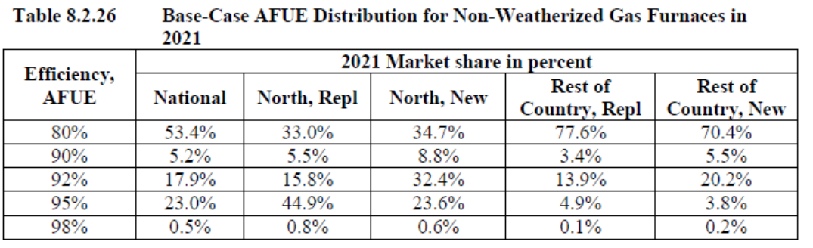

DOE assumptions on California HDD and space heating load are reasonable
The dataset that DOE uses provides a reasonable estimation of the California climate, as determined by comparing heating degree days from the dataset to the Joint Appendices of Title 24.
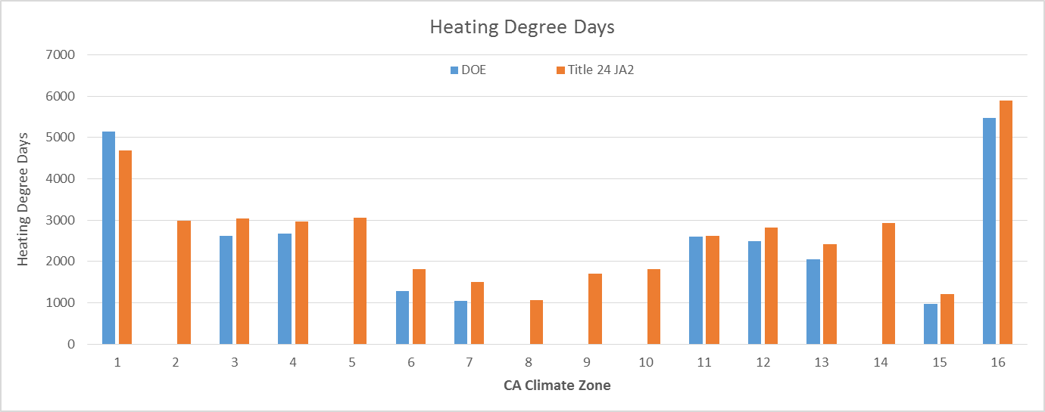
However, the distribution of annual heating load from the DOE sample is noticeably greater than the Residential Appliance Saturation Study (RASS 2009) sample. Most homes in the DOE sample have an annual heating load between 15 and 25 MMBtu, while in the RASS sample most homes are between 0-10 MMBtu.
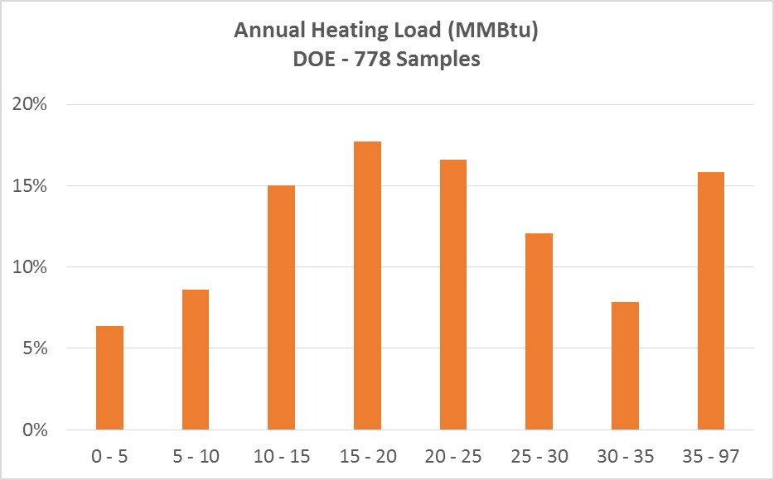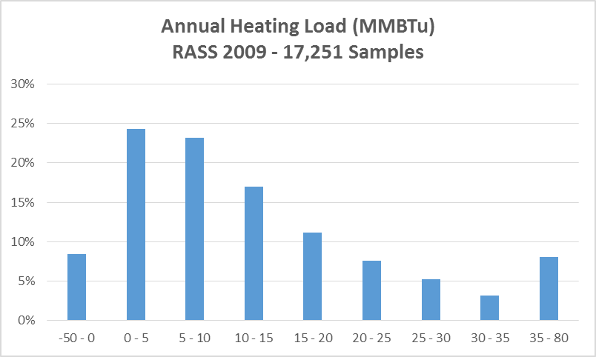
The RASS sample oddly indicates that 8% of homes have a negative annual heating load. This may be a result of their statistical methods used to determine the annual heating load with the home attributes attained from their survey.

U.S. Department of Energy, Technical Support Document: Energy Efficiency Program for Consumer Products and Commercial and Industrial Equipment: Residential Furnaces. 2015. Available at: http://www.regulations.gov/#!documentDetail;D=EERE-2014-BT-STD-0031-0027
U.S. Department of Energy, Technical Support Document: Energy Efficiency Program for Consumer Products: Residential Water Heaters, Direct Heating Equipment, and Pool Heaters. 2009. Available at: http://www.regulations.gov/#!documentDetail;D=EERE-2006-STD-0129-0170
EER Consulting, L., Appendix 8-B (Section 8-B.5) part of Final Rule Technical Support Document: Energy Efficiency Standards for Consumer Products: Central Air Conditioners, Heat Pumps, and Furnaces. 2010. Dallas, TX. Available at: http://www.regulations.gov/#!documentDetail;D=EERE-2011-BT-STD-0011-0012
U.S. Department of Energy: Energy Information Administration, Annual Energy Outlook 2014 with Projections to 2040. 2014. Washington, DC. Available at: www.eia.gov/forecasts/aeo/
Available at: http://energyalmanac.ca.gov/electricity/web_qfer/Heat_Rates.php
Available at: http://www.cpuc.ca.gov/PUC/energy/Renewables/
U.S. Department of Energy, Technical Support Document: Energy Efficiency Standards for Consumer Products: Central Air Conditioners, Heat Pumps, and Furnaces. 2011. Available at: http://www.regulations.gov/#!documentDetail;D=EERE-2011-BT-STD-0011-0012

